

**WEEK-7 ASSIGNMENT**

-Riddhima Bhanja

Kalinga Institute of Industrial Technology

Bhubaneswar(Java Track)

INDEX

| **Content** | **Page No.** |
| --- | --- |
| **1. JACOCO Code Coverage Report** | 1 |
| **2. SonarQube Report & Issues** | 3 |
| **3. System Architecture, ER Diagram** | 5 |
| **4. JMeter & RabbitMQ dashboard** | 6 |
| — JMeter Result Tree | 6 |
| — JMeter Summary Report | 6 |
| — Apache JMeter Dashboard | 7 |
| **5. Logs** | 9 |
| — RabbitMQ Dashboard | 9 |
| — Eureka server, Booking Service | 10 |
| — Flight Service, API Gateway, Notification service | 10 |
| **6. MongoDB Screenshots** | 11 |
| **7. Postman Screenshots** | 11 |
| — Circuit Breaker, Message broker | 11 |
| — — JWT security through API Gateway | 12 |
| — — Status,Events | 12 |
| — Health Checks | 13 |
| — — API Gateway Health | 13 |
| — — Booking Service Health | 13 |
| — — Eureka Server Health | 14 |
| — — Flight Service Health | 14 |
| — Add Flight | 15 |
| — Book Flight, get flight by PNR, get flight by ID | 15 |
| — Cancel Booking, FALLBACK CASE | 15 |
| — Get Booking by PNR | 16 |
| — Get Booking History | 16 |
| **8. Email** | 17 |
| — With PDF | 17 |
| — Without PDF | 17 |
| — Fallback Case | 17 |
| **9. Eureka Dashboard, MySQL Workbench** | 17 |

JACOCO REPORTS

FLIGHT SERVICE:

98% COVERAGE

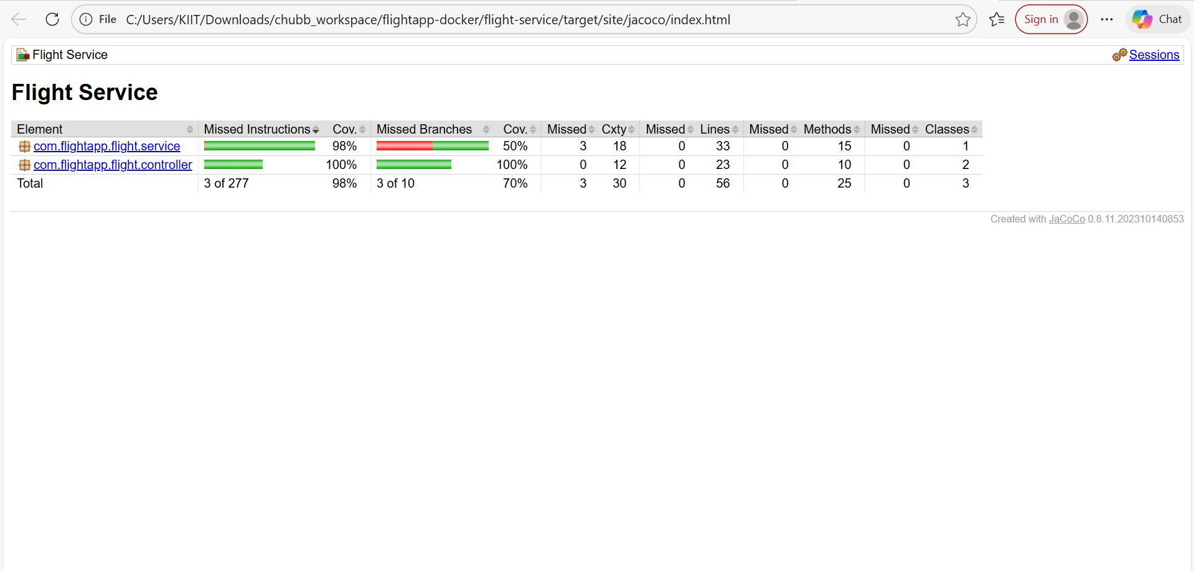

BOOKING SERVICE

**94% coverage**

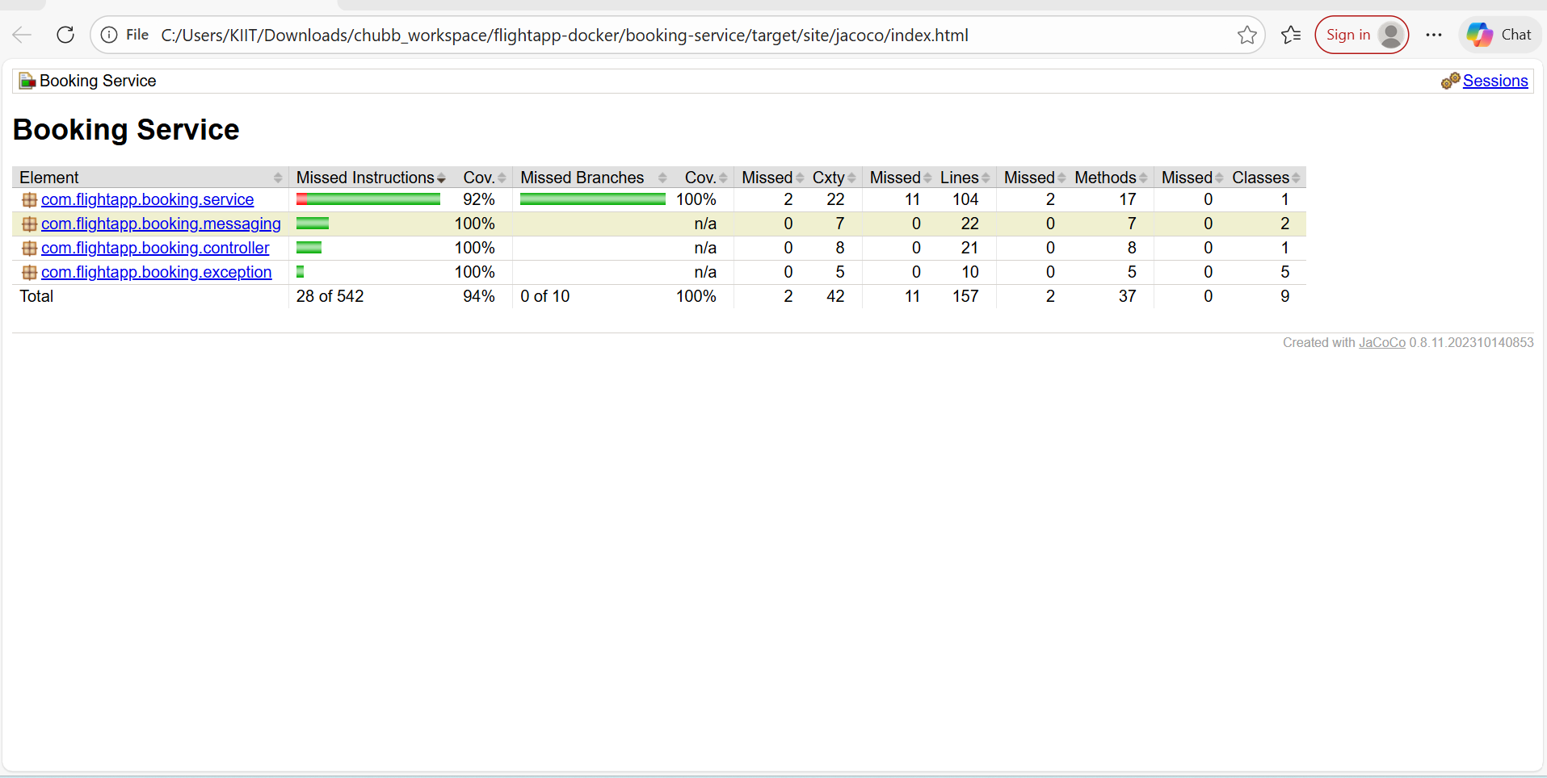

**ER DIAGRAM**

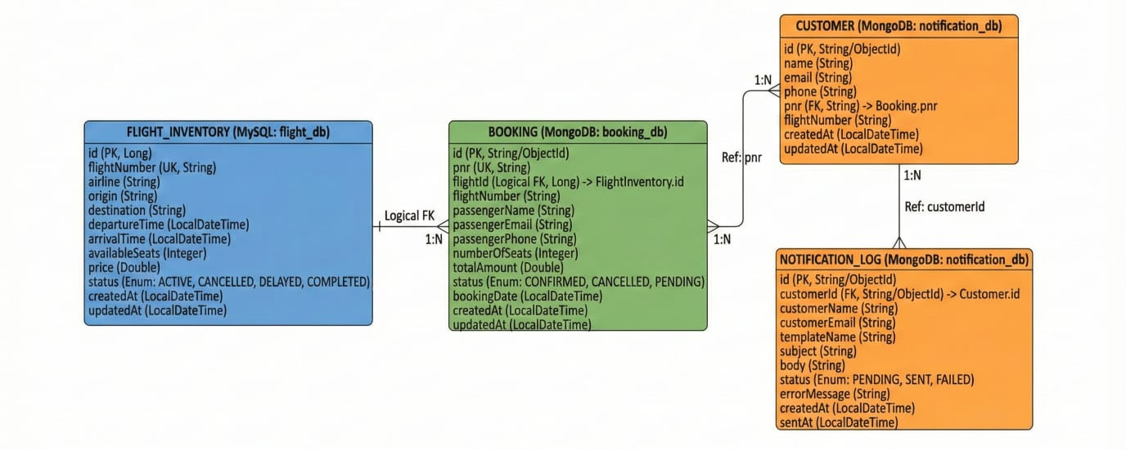

1. SonarQUBE Code Coverage

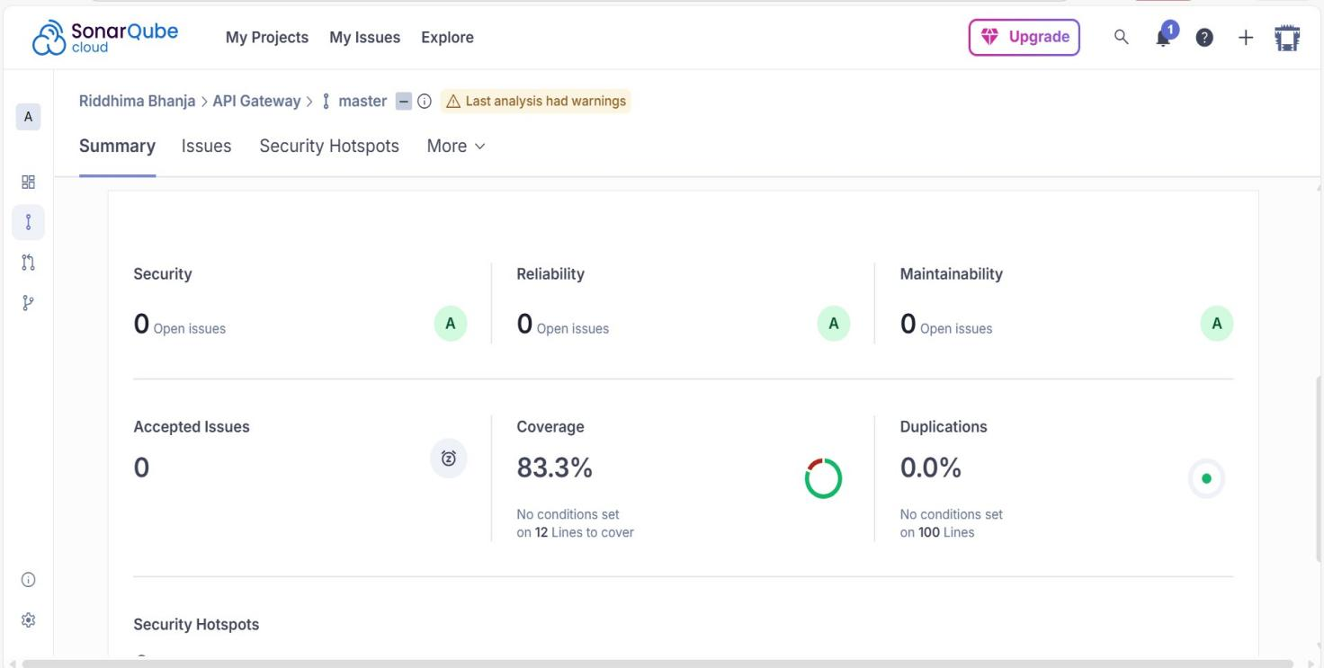

1. SonarQube Issues

**Before fixing:**

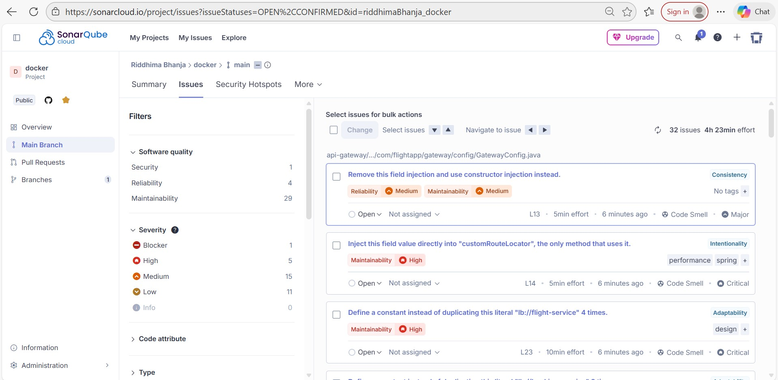

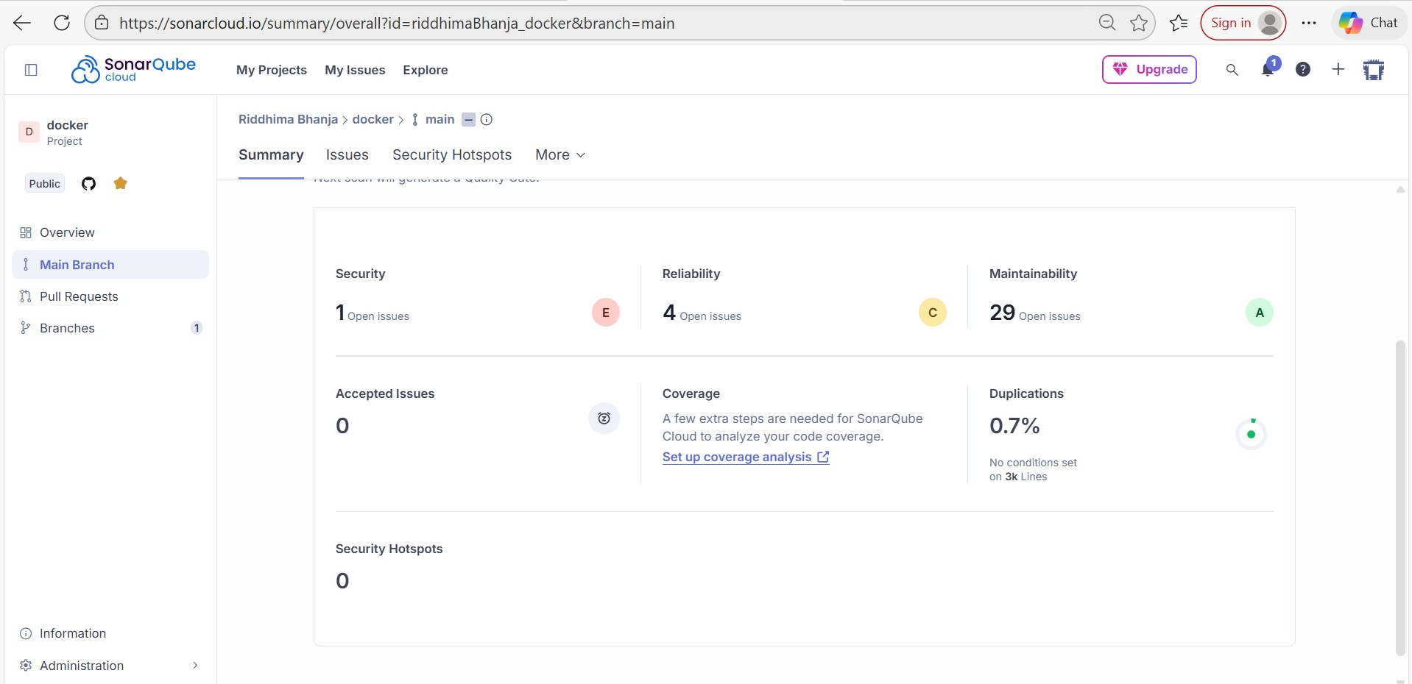

**After fixing:**

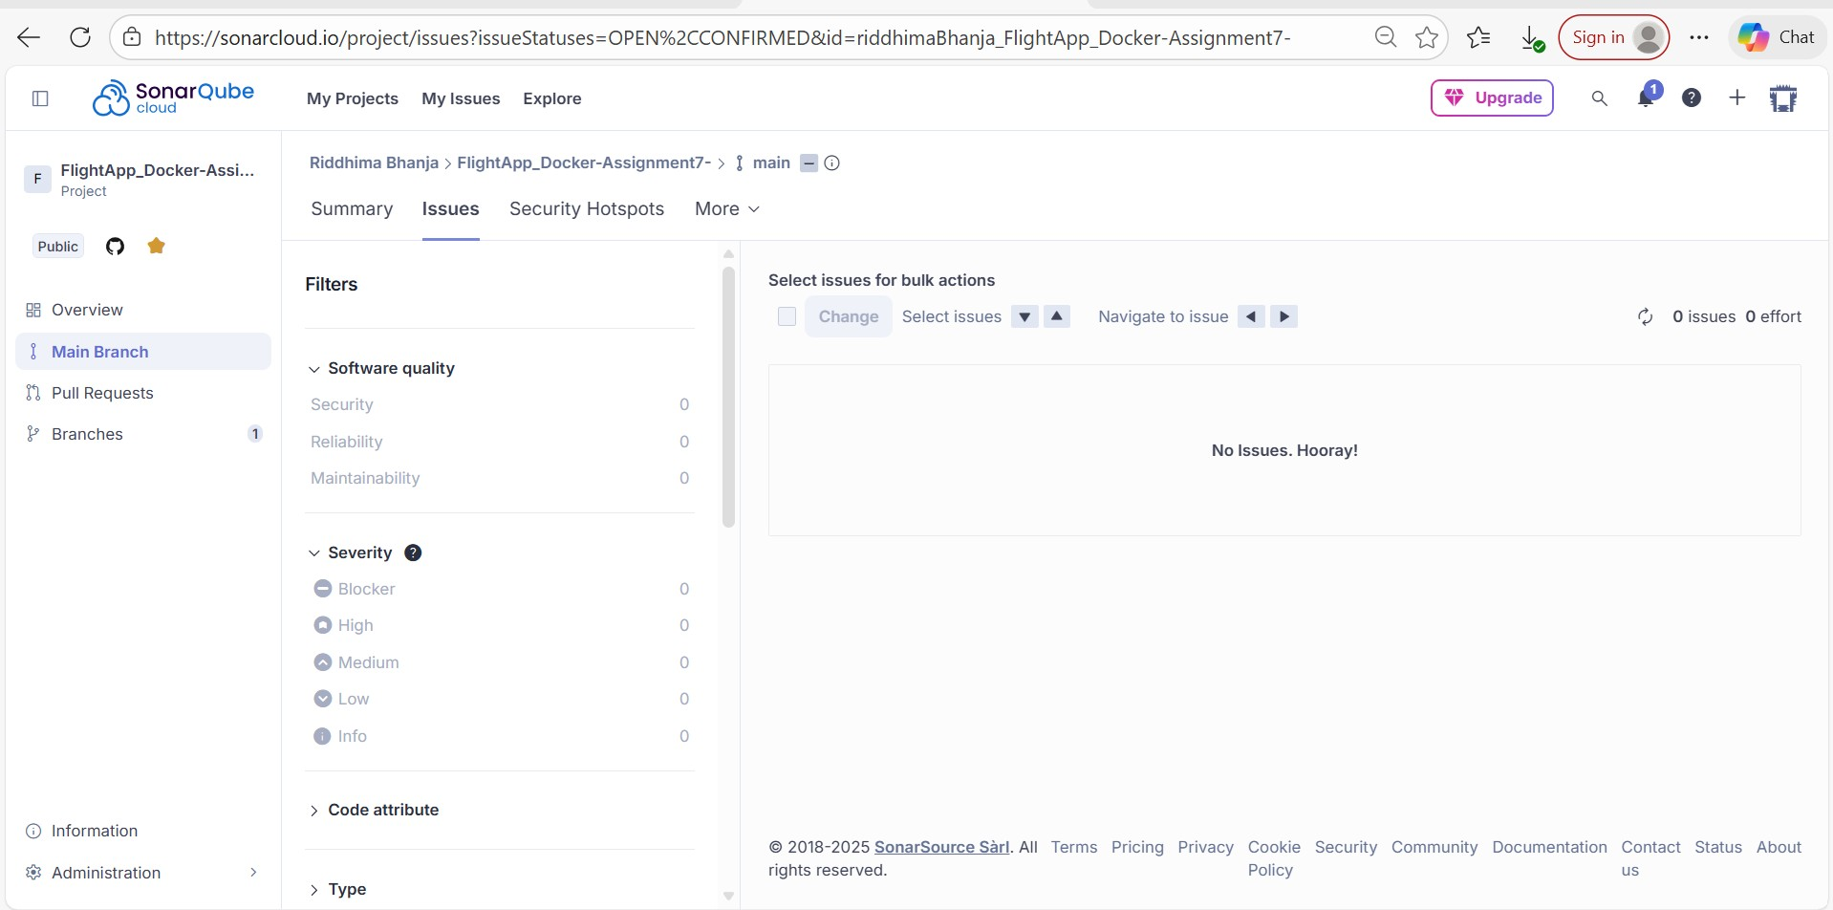

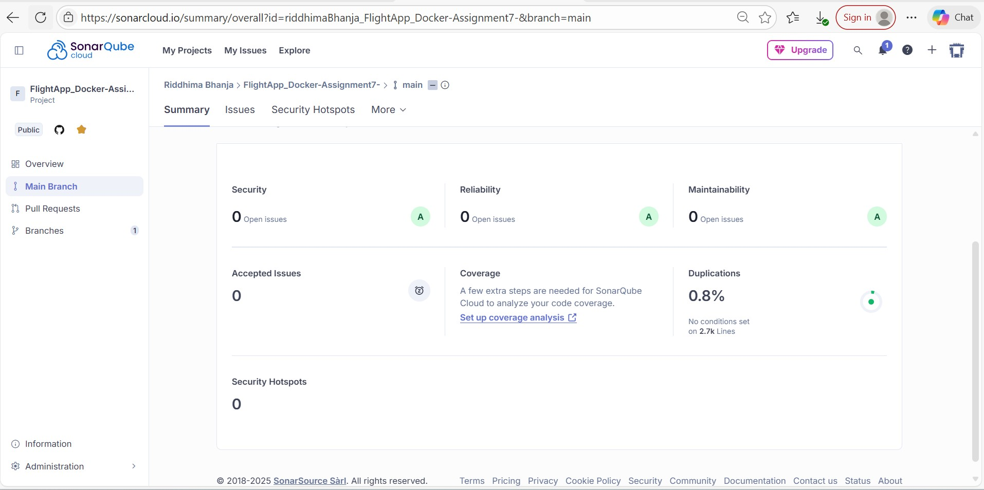

1. System Architecture

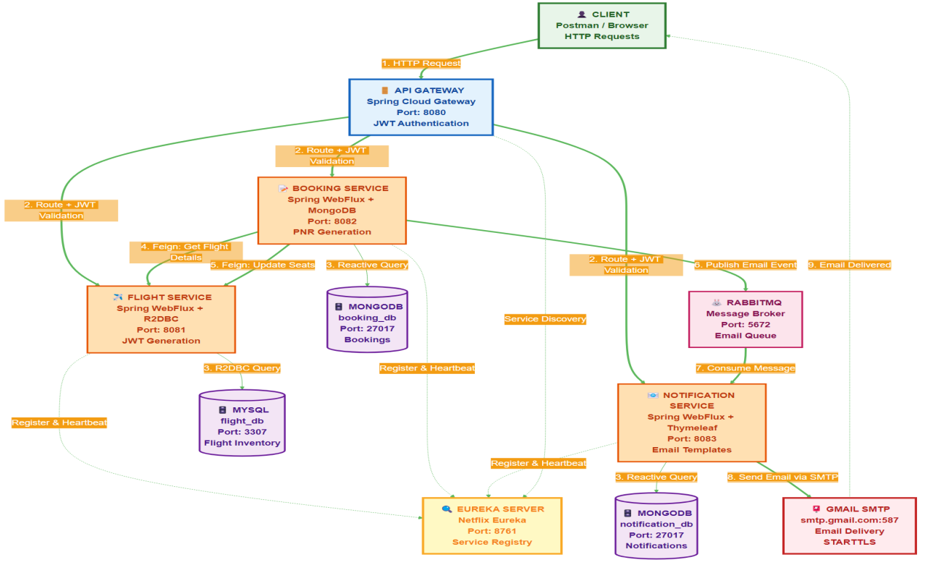

1. Jmeter

* Apache Jmeter Dashboard

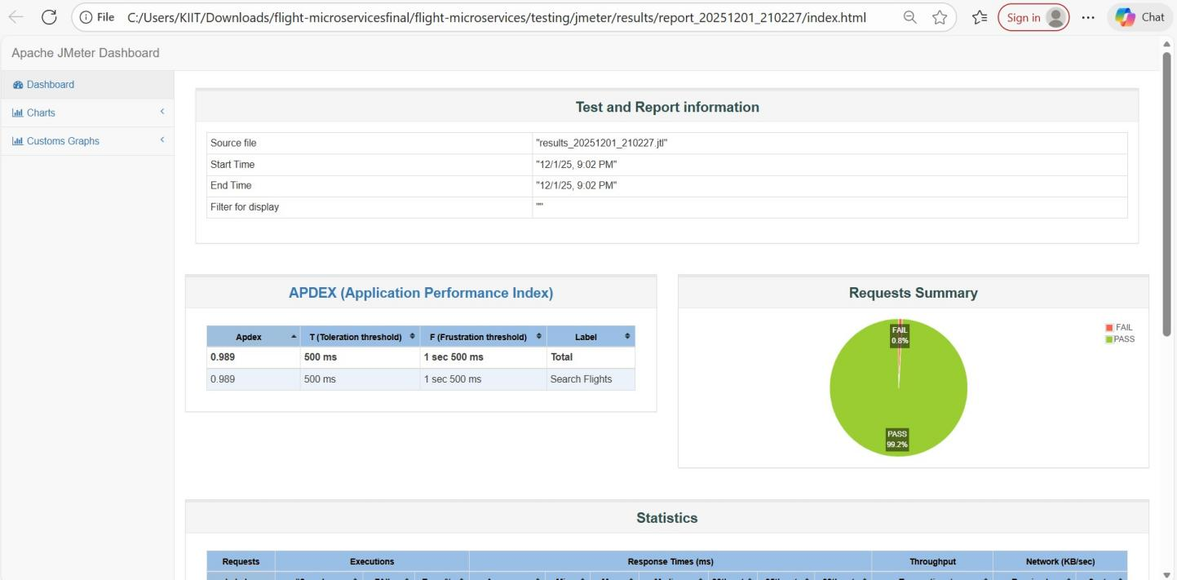

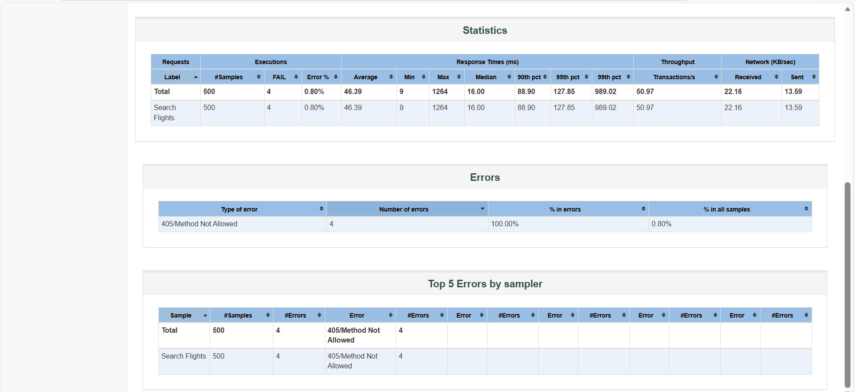

LOGS SCREENSHOTS

DASHBOARD

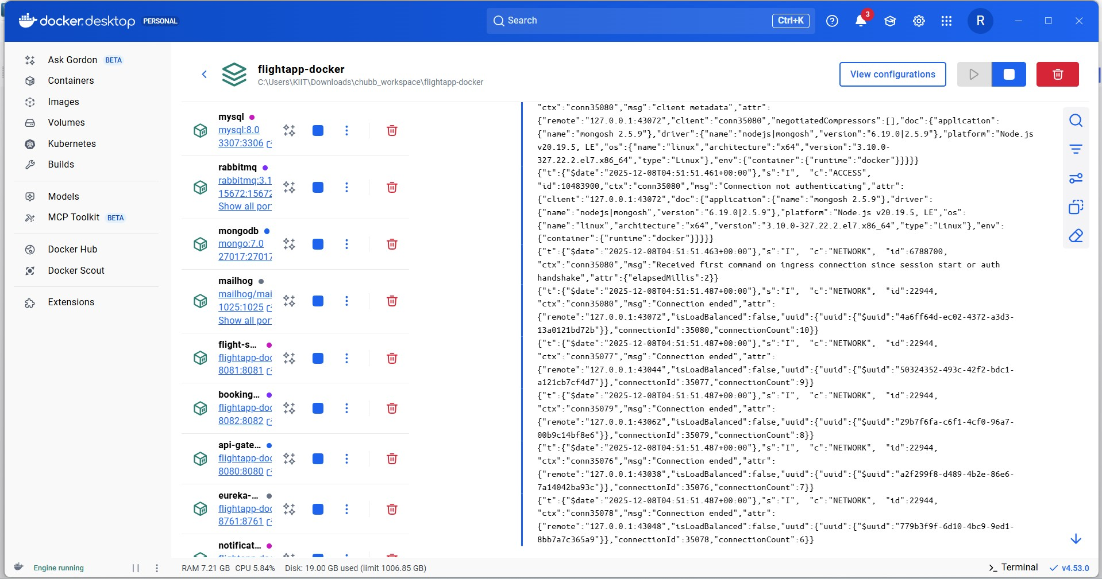

EUREKA SERVER LOGS

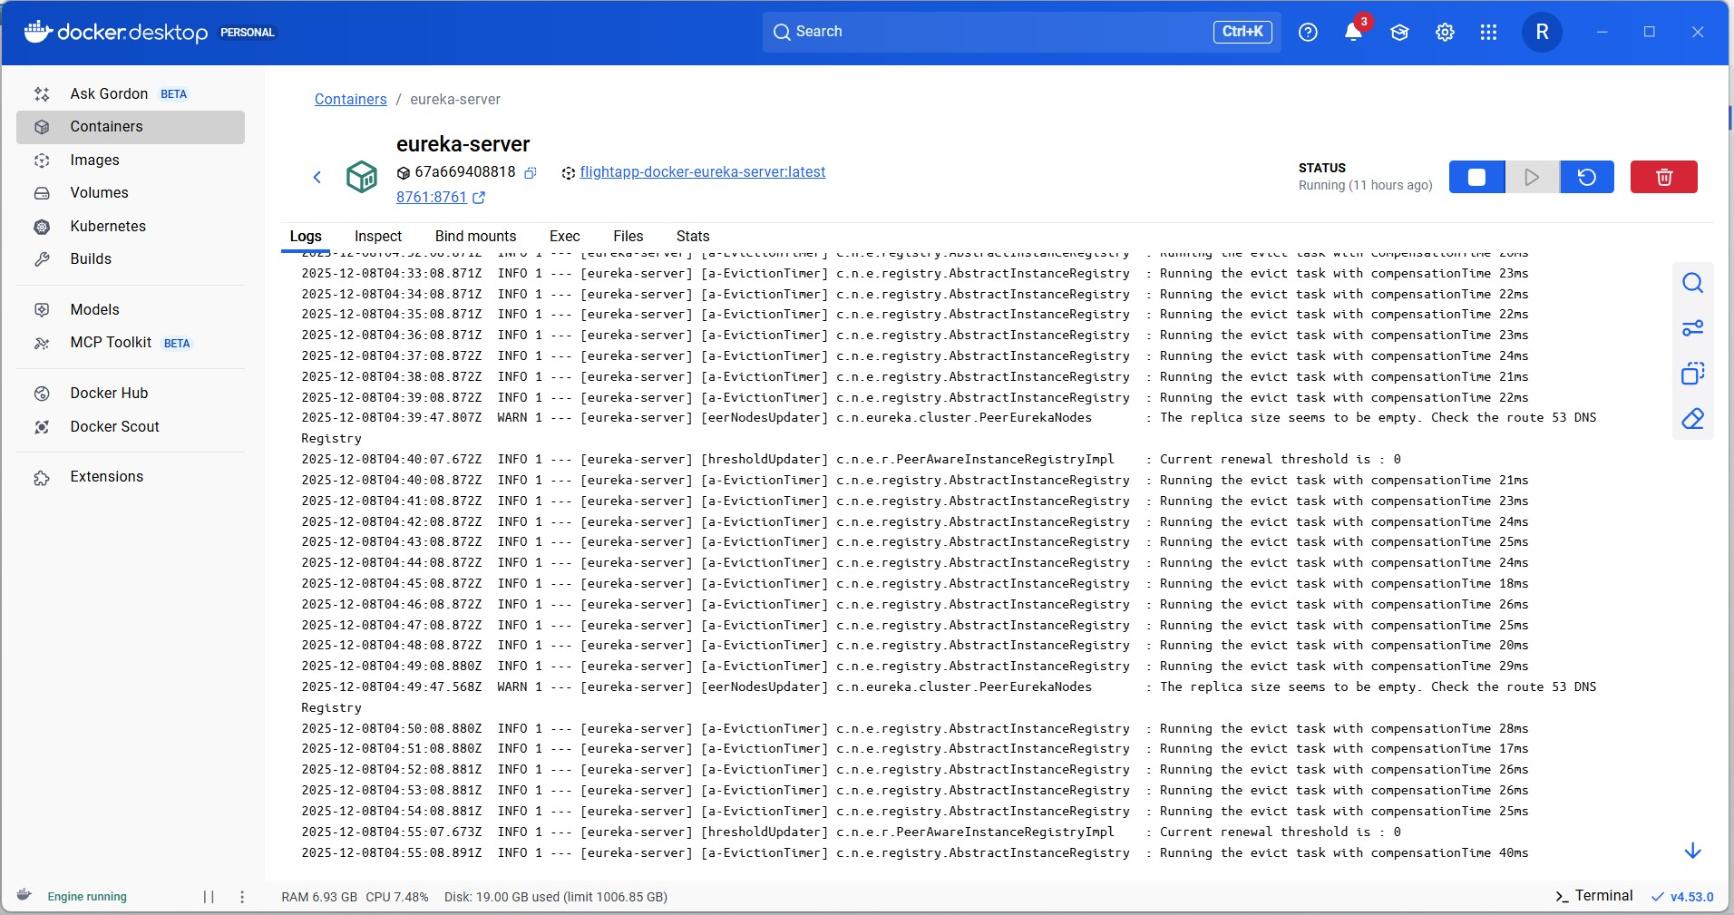

API GATEWAY

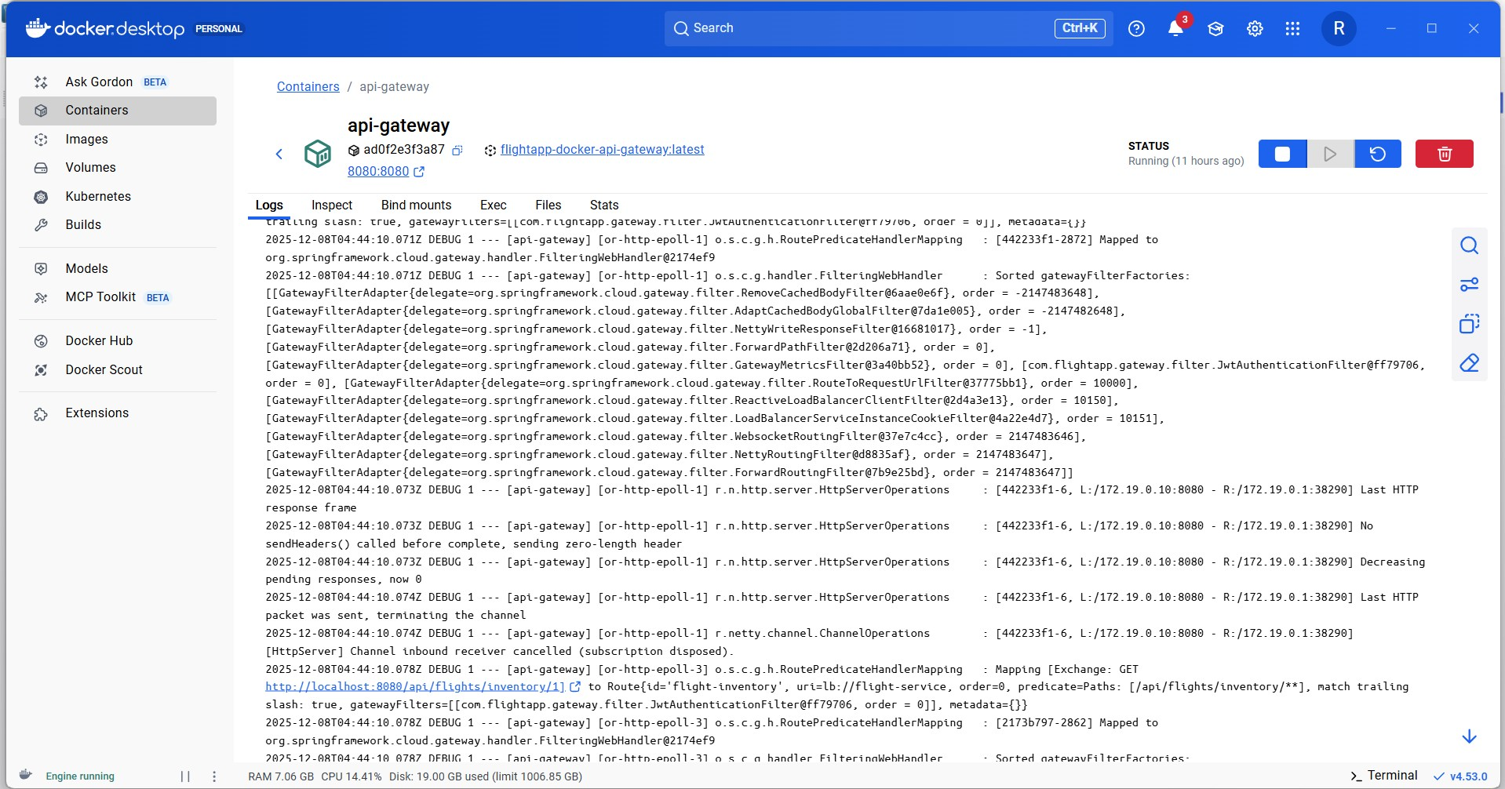

BOOKING SERVICE LOGS

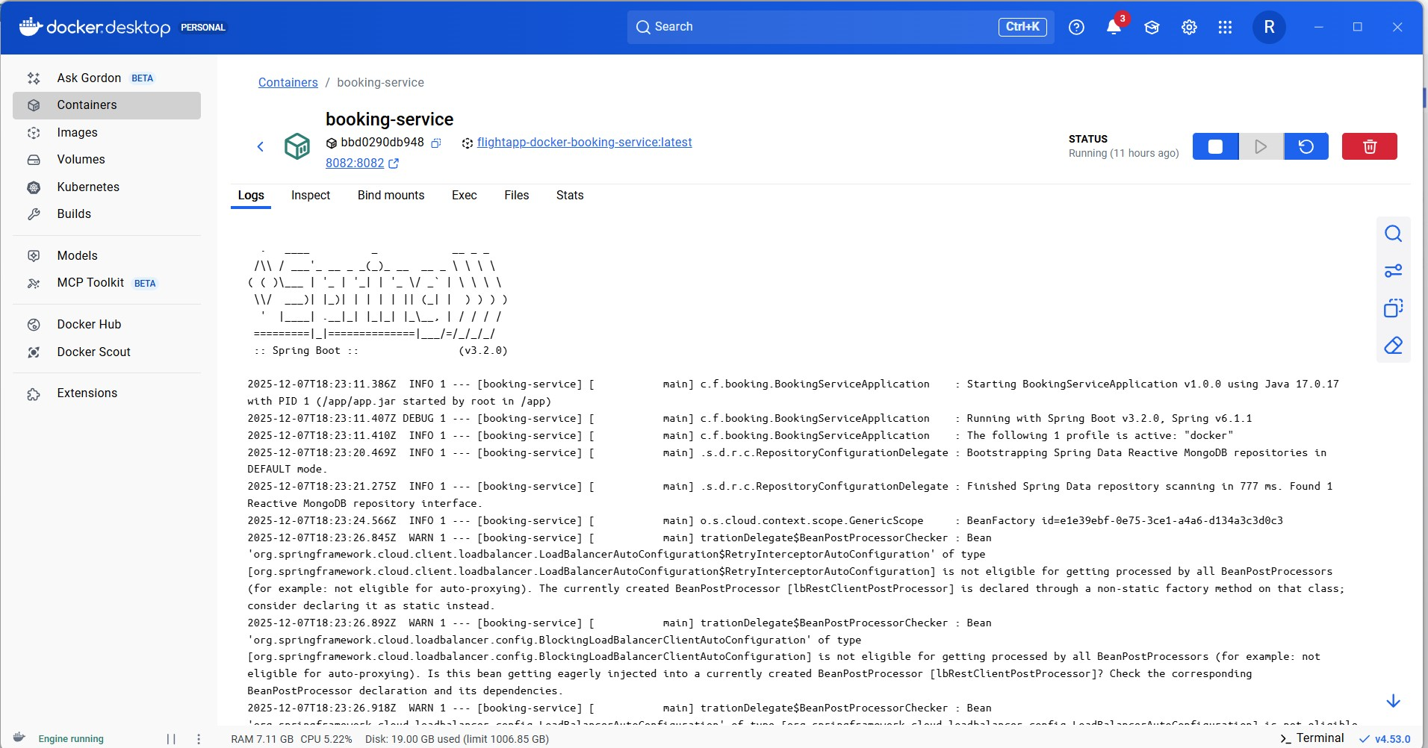

FLIGHT SERVICE LOGS

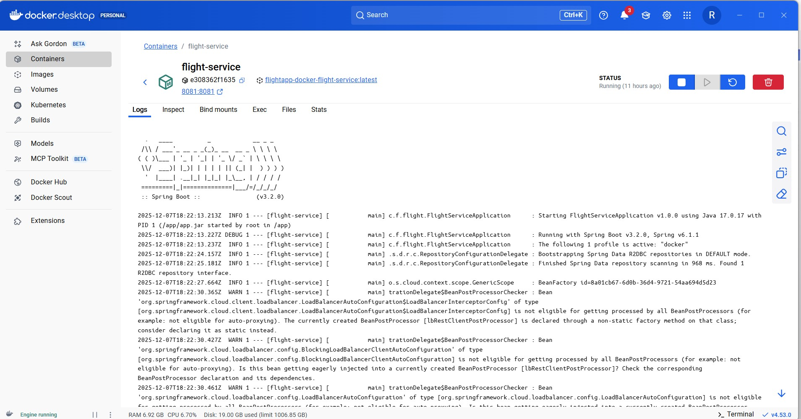

NOTIFICATION SERVICE LOGS

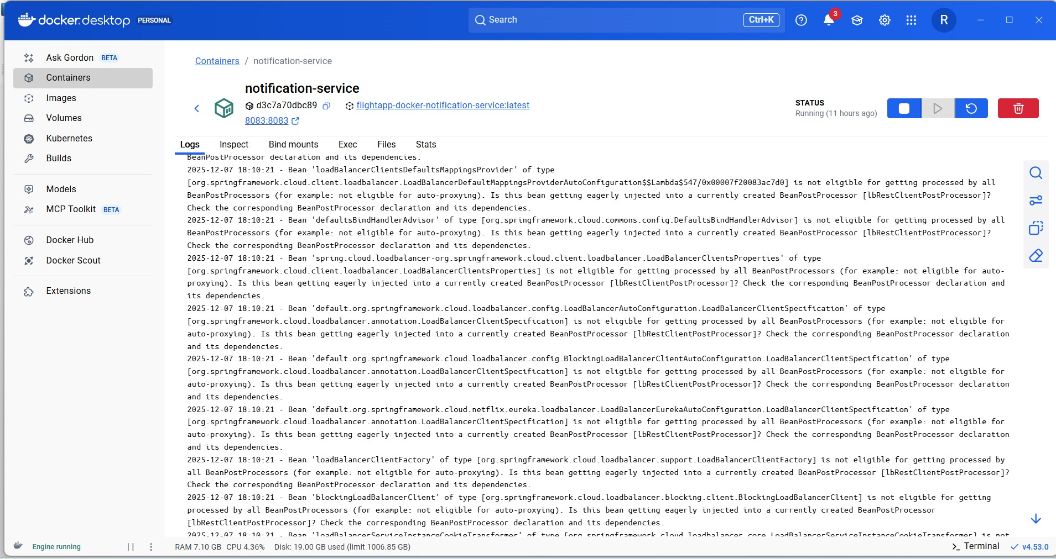

RabbitMQ logs

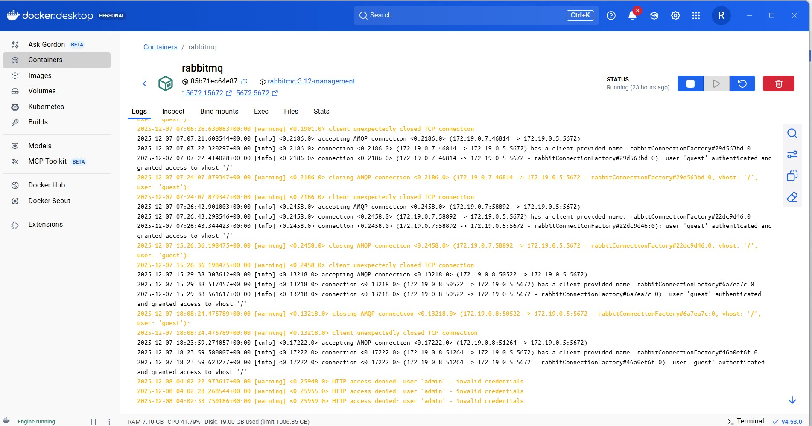

Mongodb logs

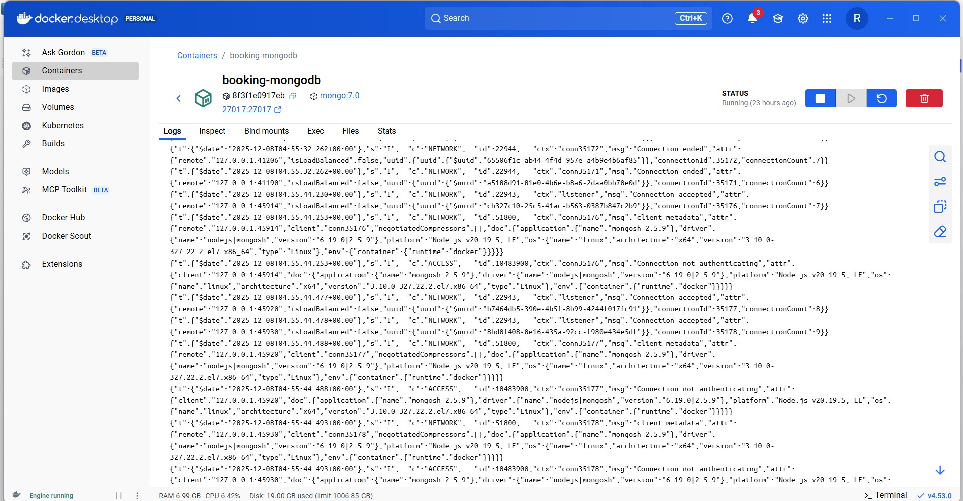

5.Mongodb screenshots

* Booking_db

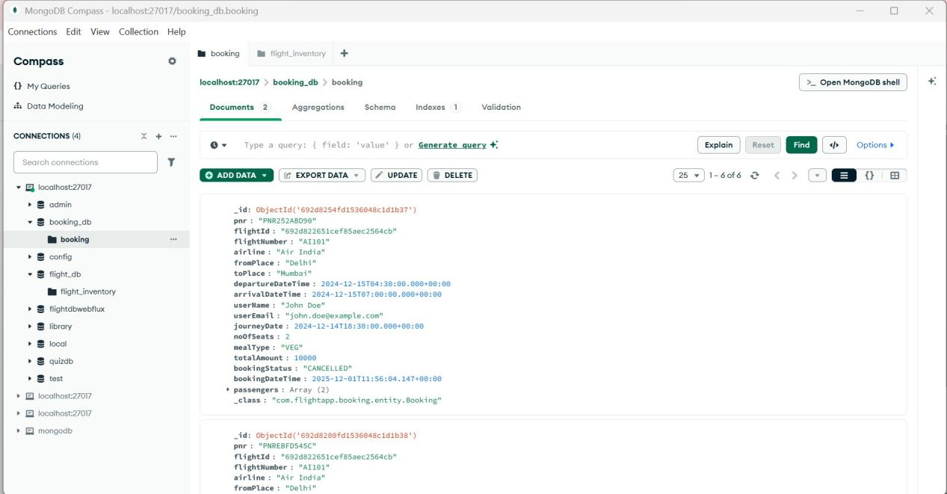

* **Flight_db**

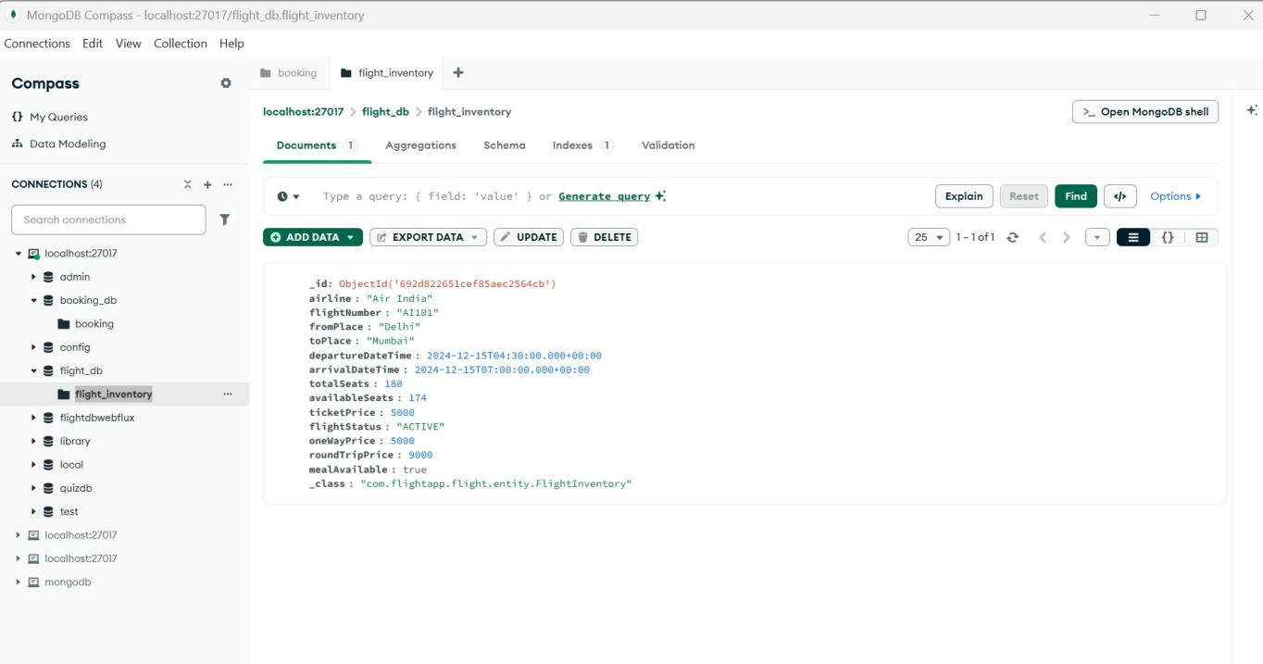

* Notification logs

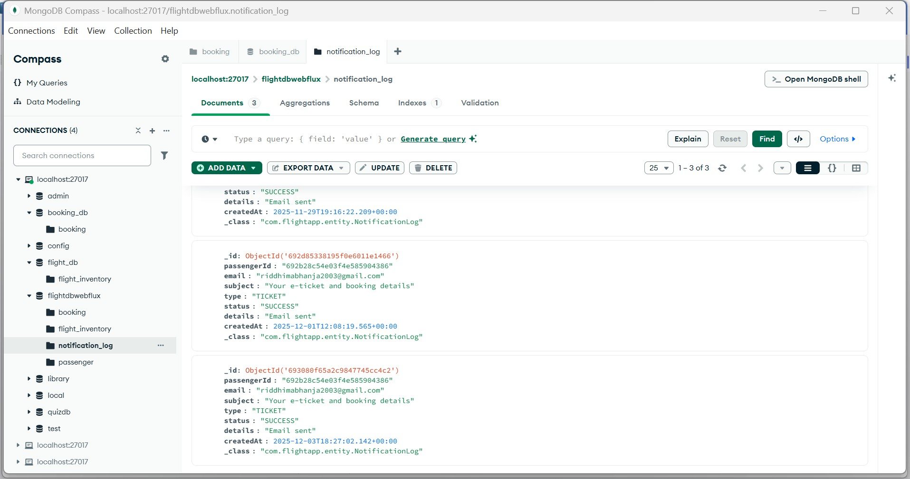

1. Email

* Welcome Email

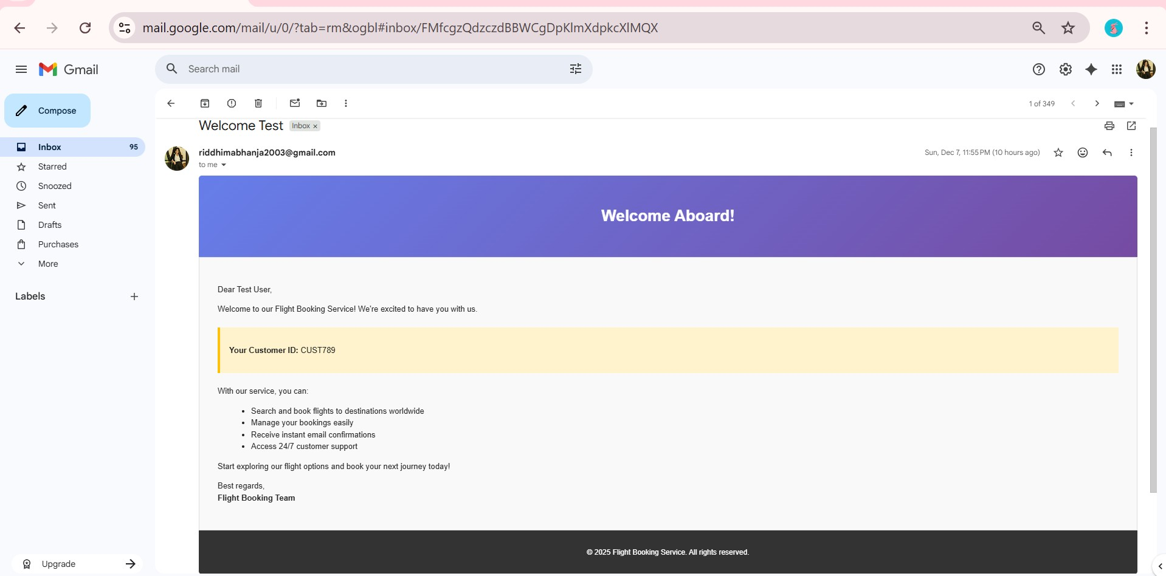

* Confirm Booking Email

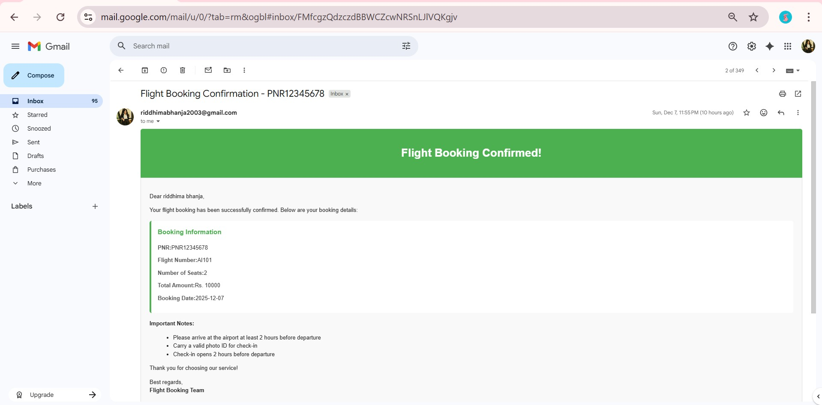

* Flight cancel email

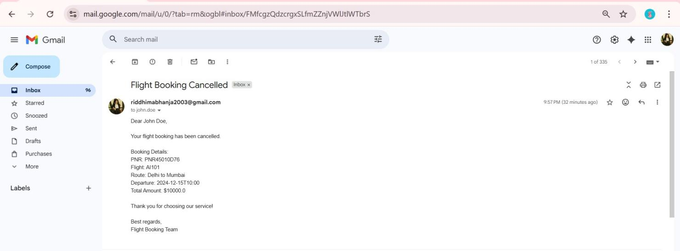

**RabbitMQ email-queue dashboard**

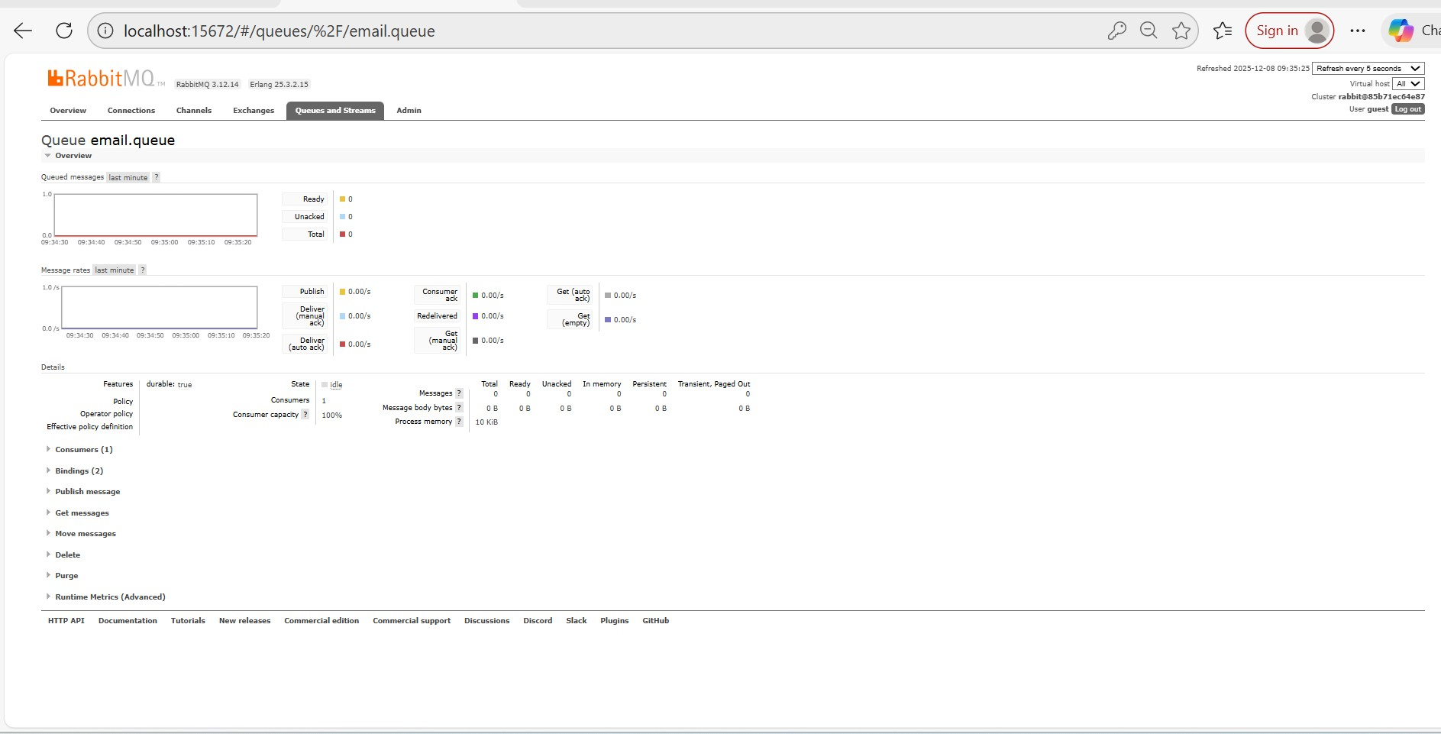

**RabbitMQ overview dashboard**

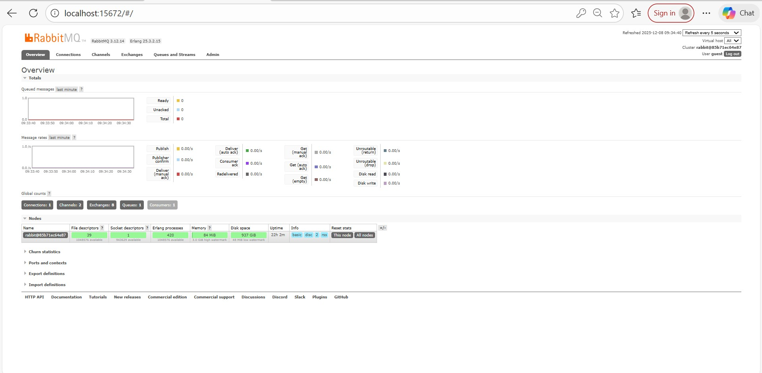

1. Postman screenshots

Obtain JWT TOKEN

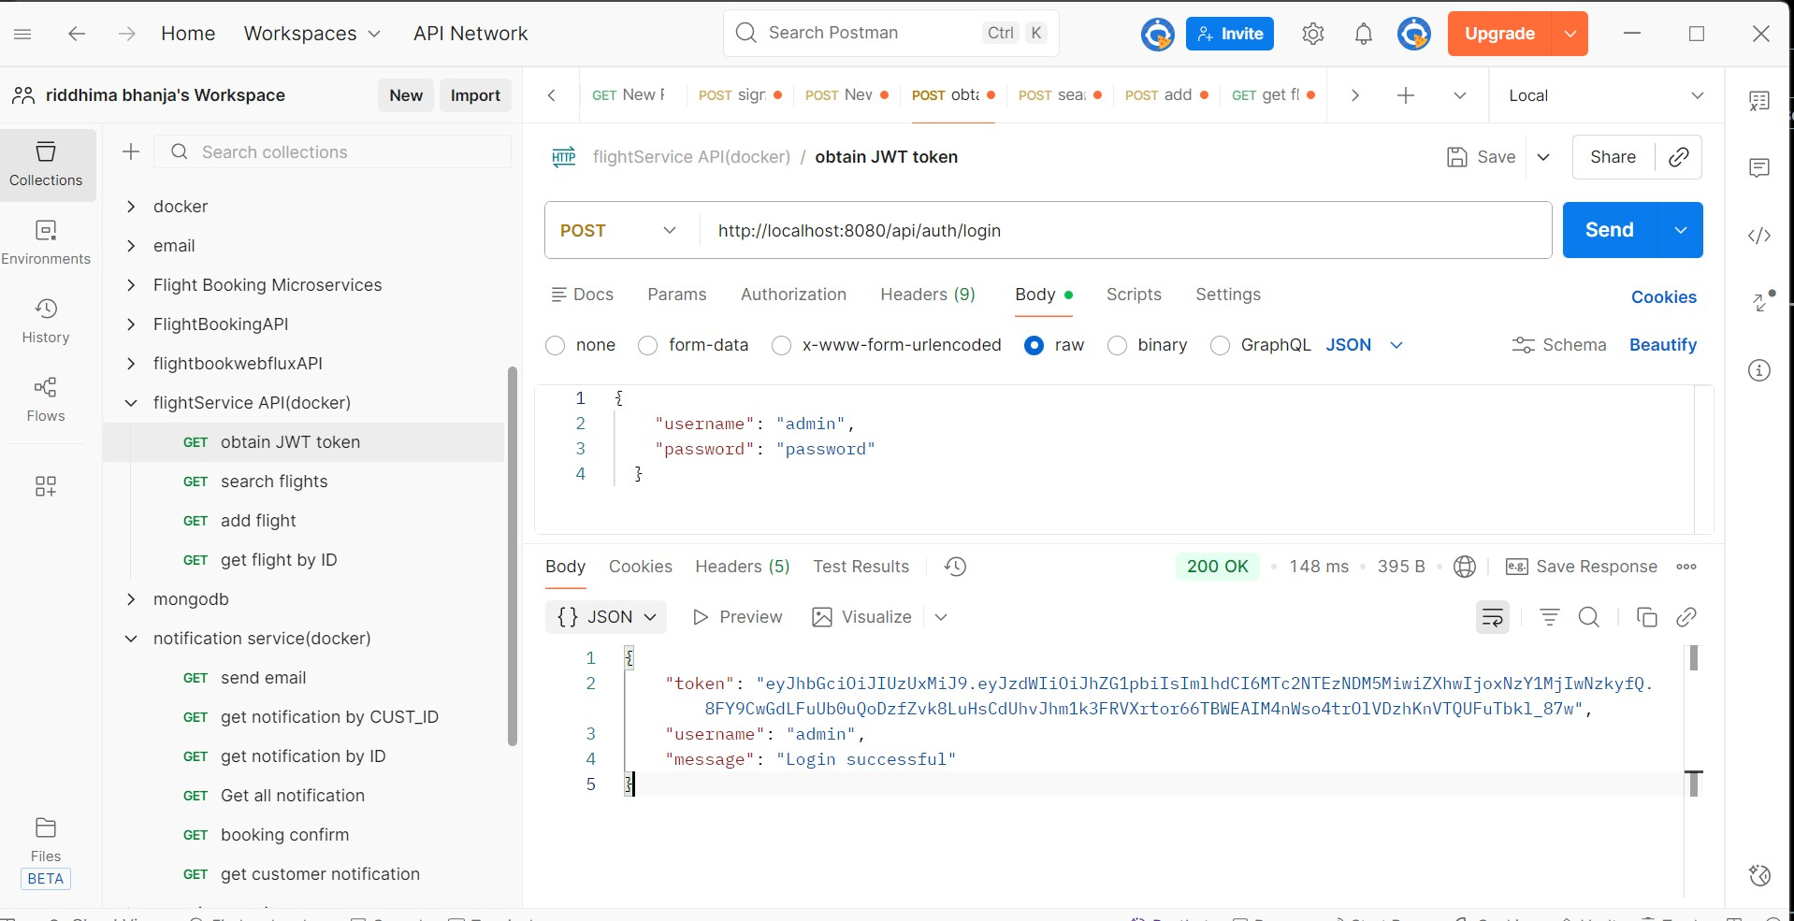

Unauthorized access

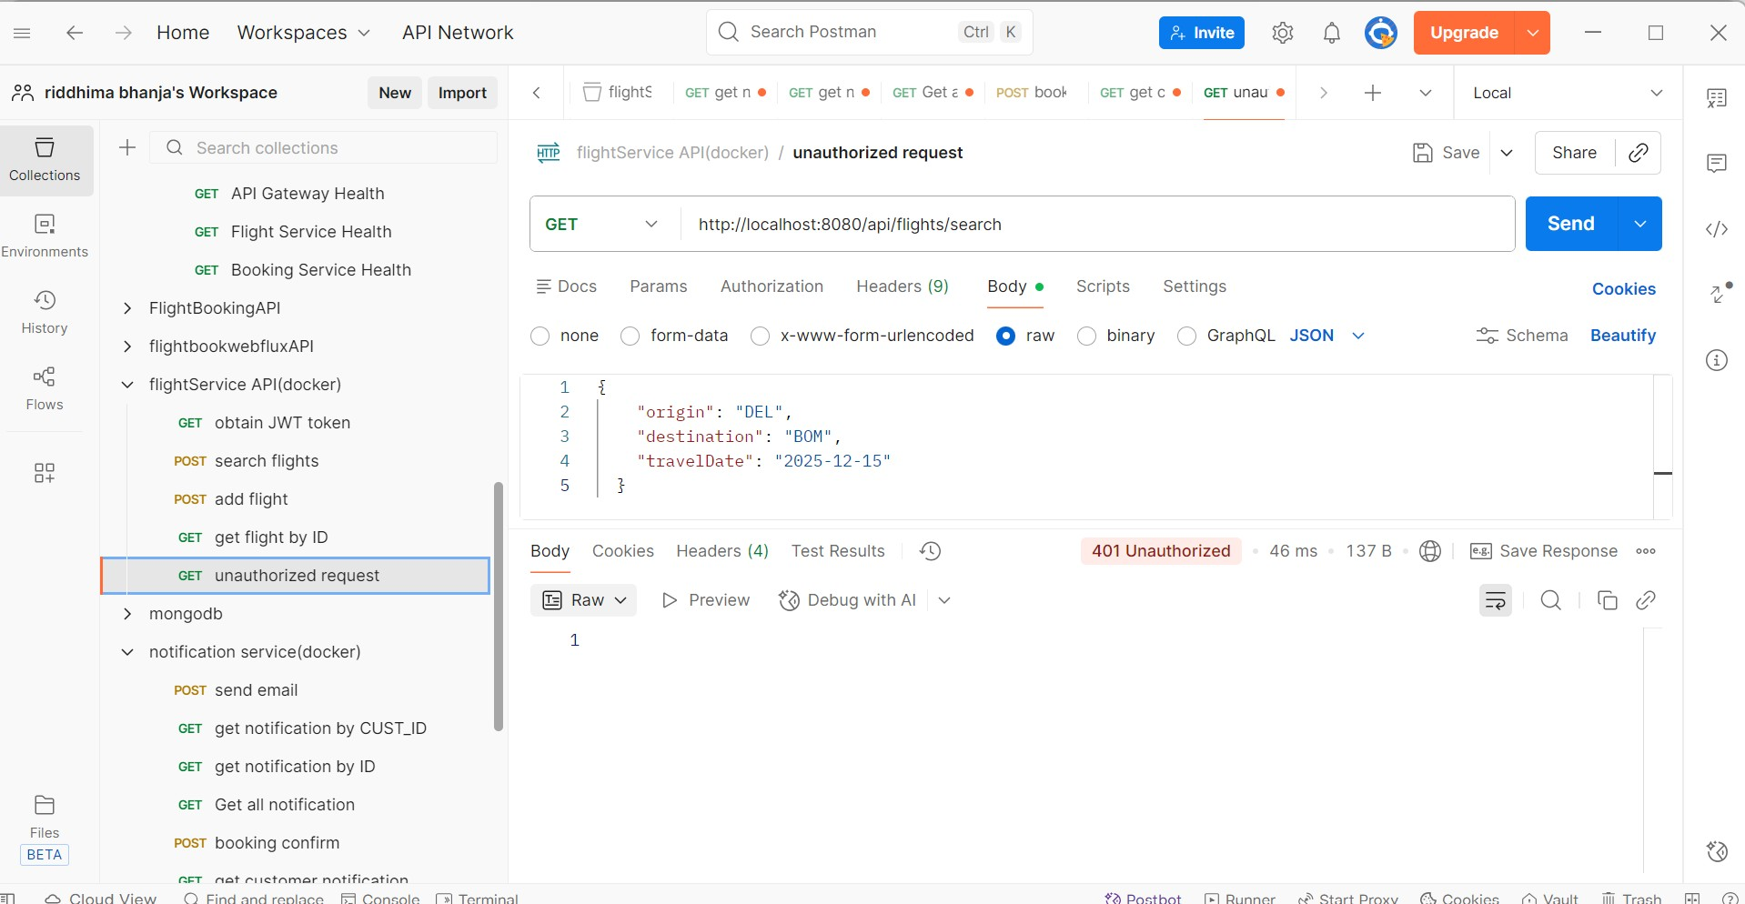

Same endpoint with auth bearer token

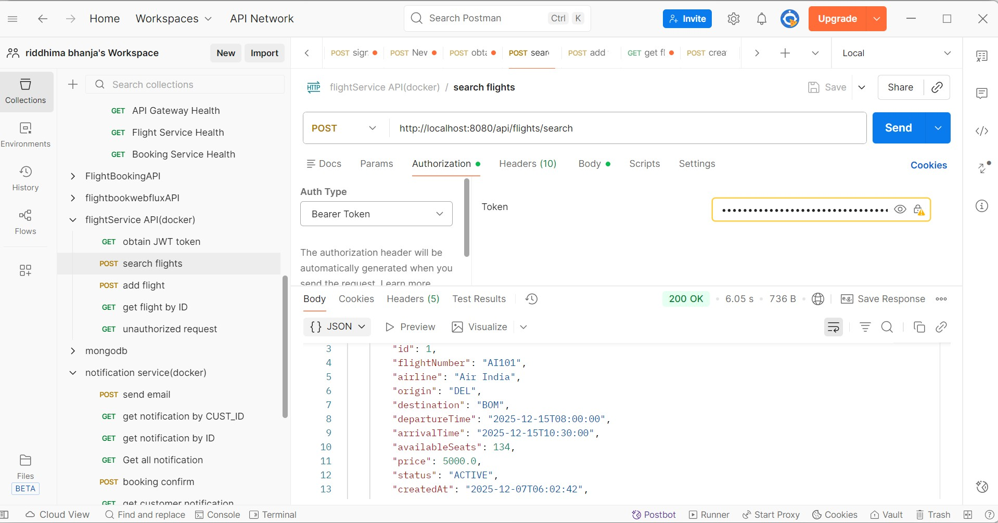

* **Circuit Breaker**

**Events:**

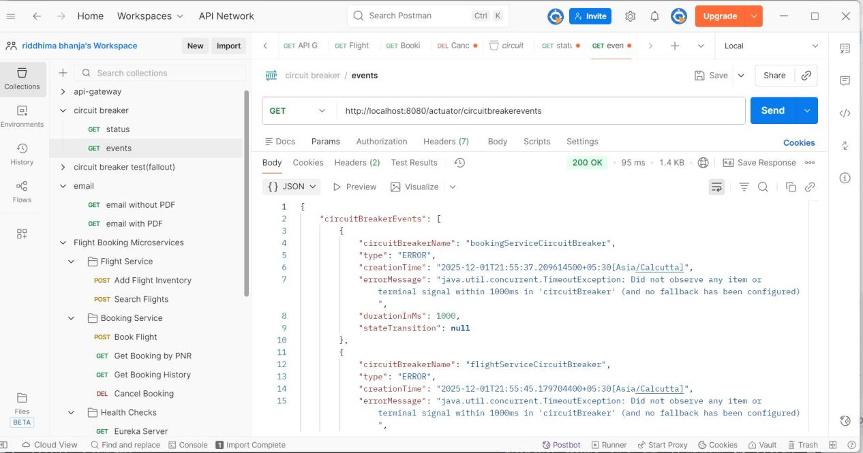

**Status:**

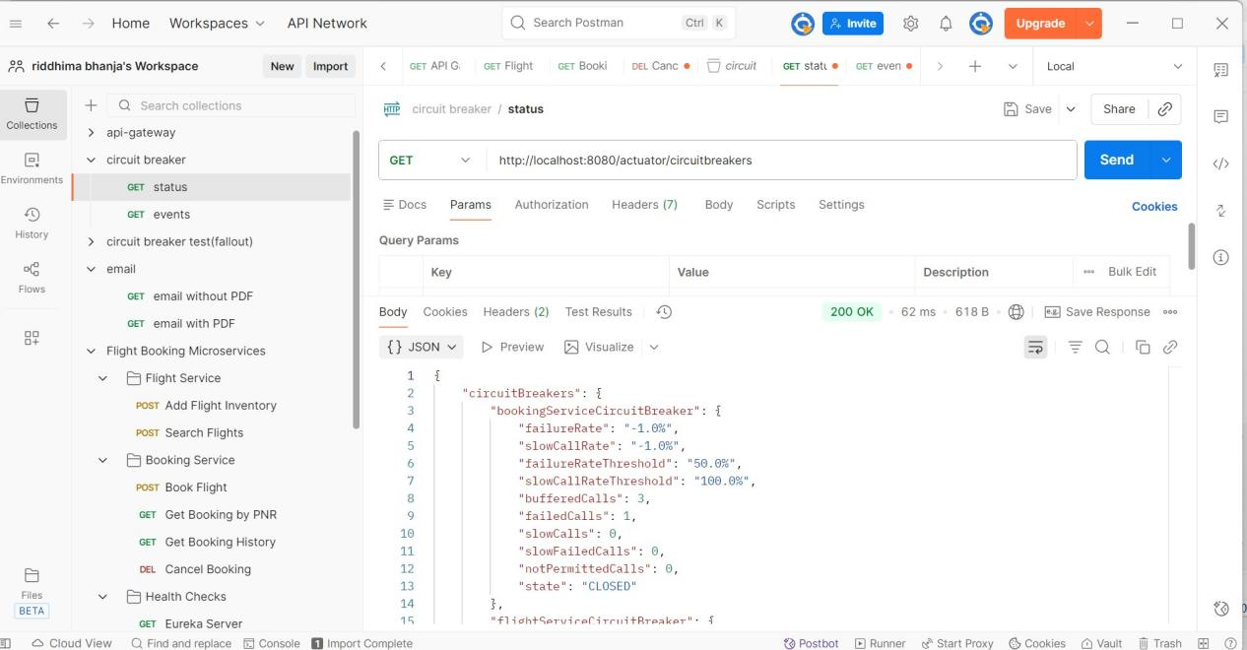

* **Health Check**

**API gateway health:**

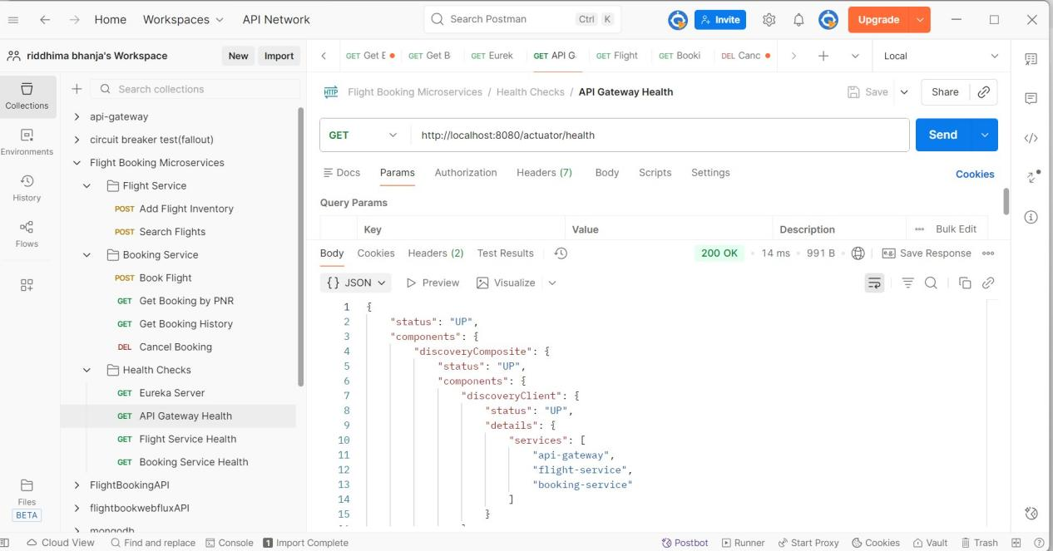

**Booking Service Health:**

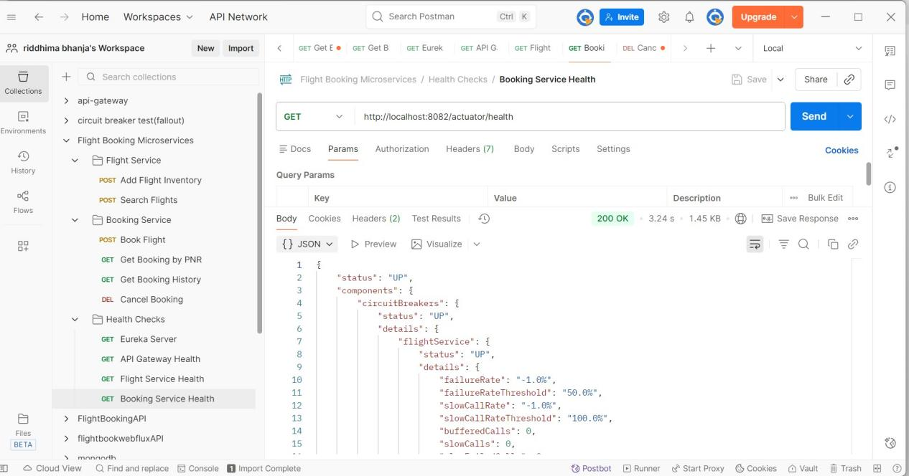

**Eureka server:**

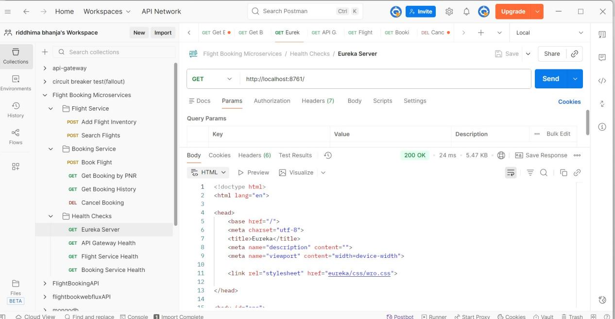

**Flight Service Health:**

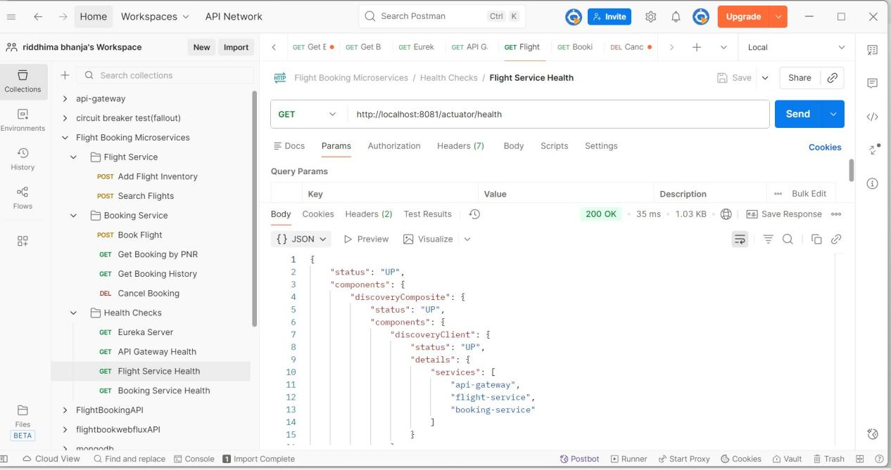

ADD FLIGHT

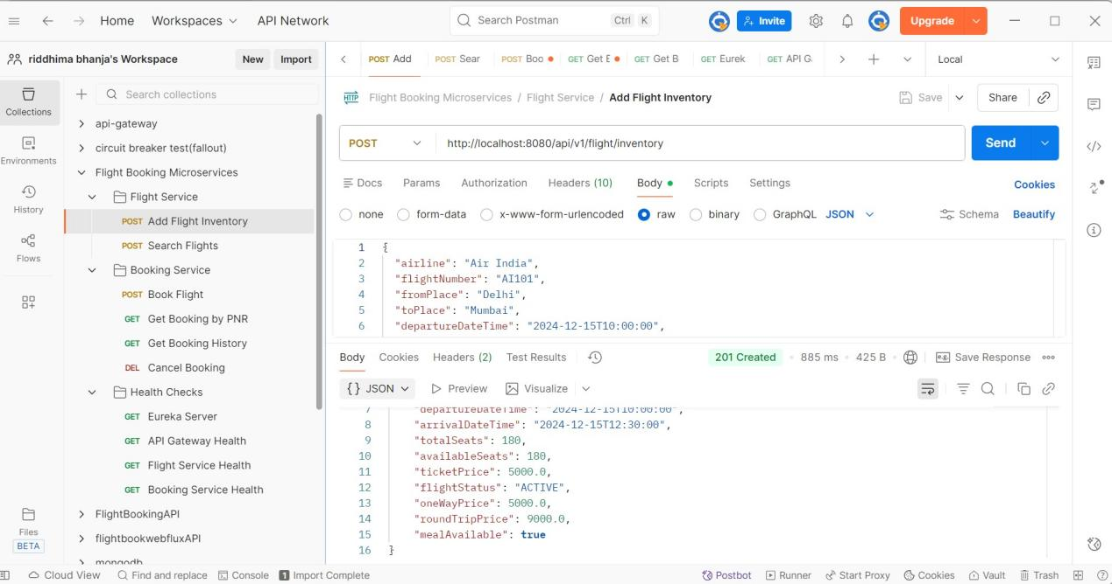

**BOOK FLIGHT**

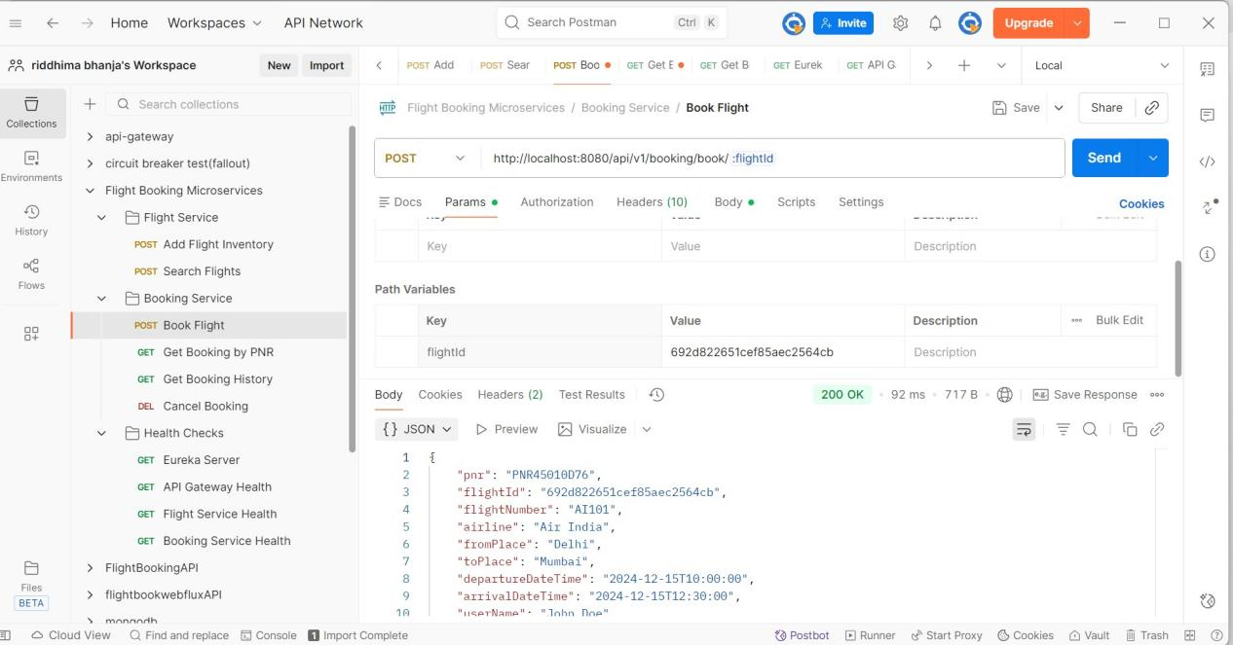

**SEARCH FLIGHTS**

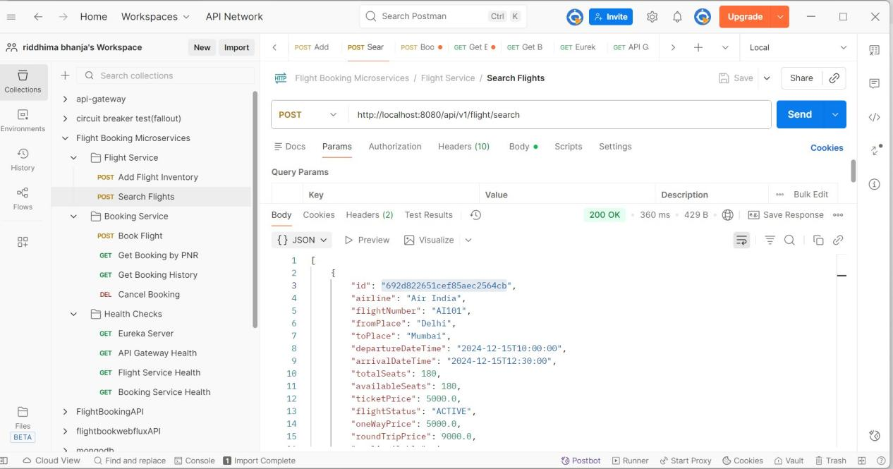

**CANCEL BOOKING**

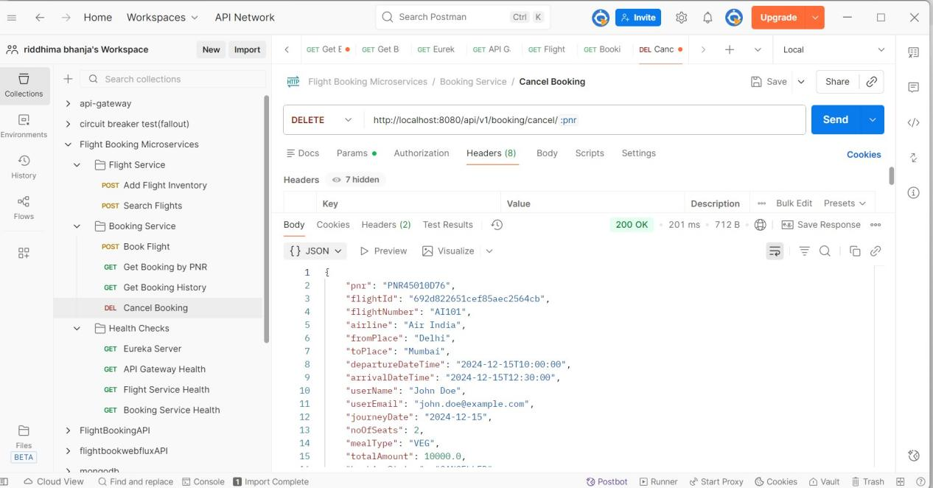

**GET BOOKING BY PNR**

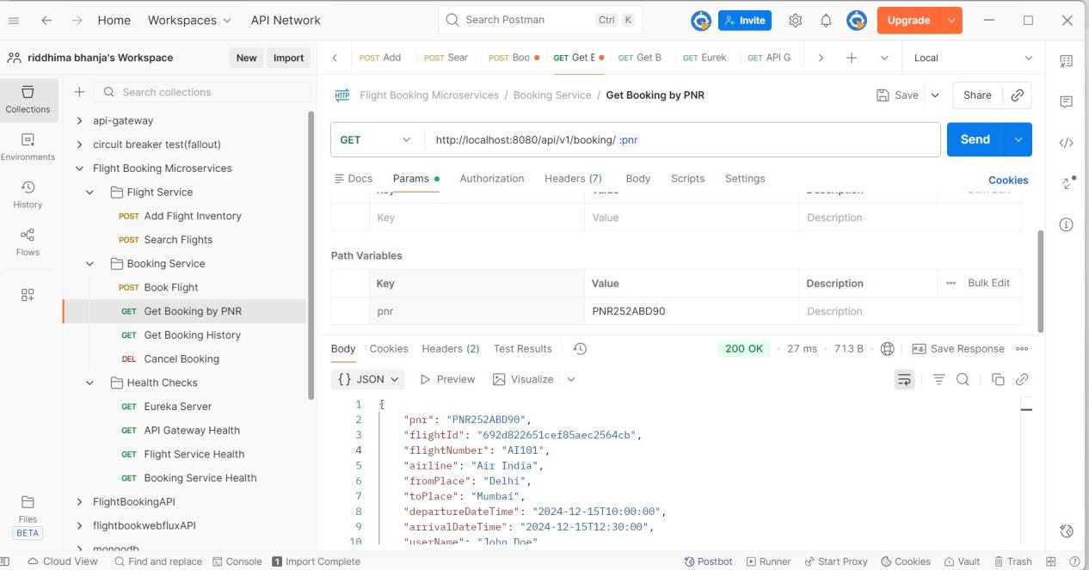

**GET BOOKING HISTORY**

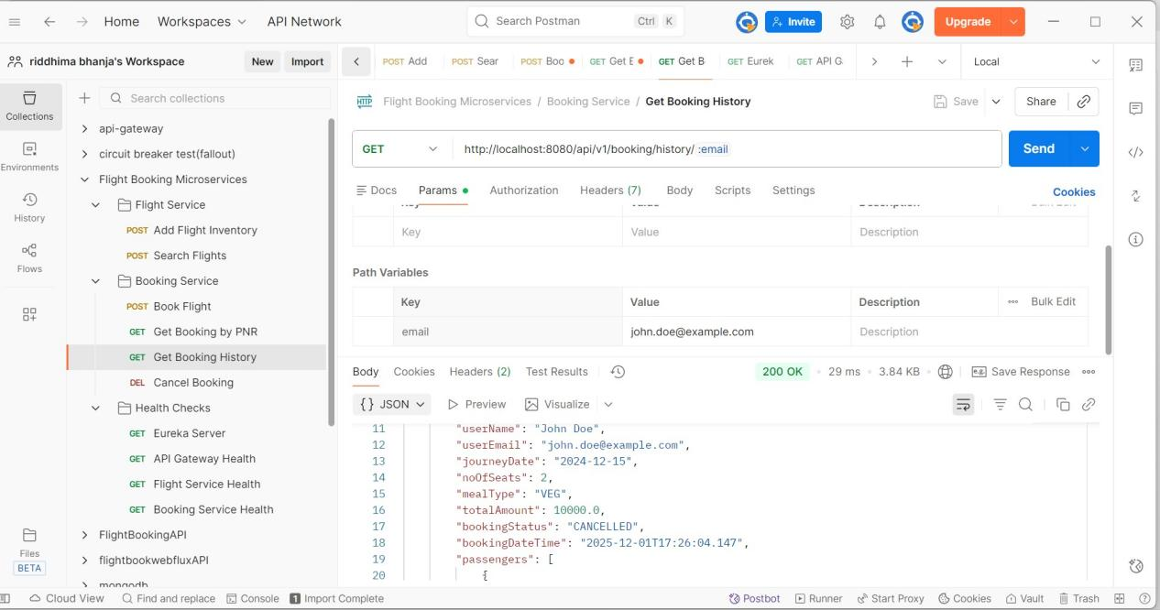

FALLBACK case

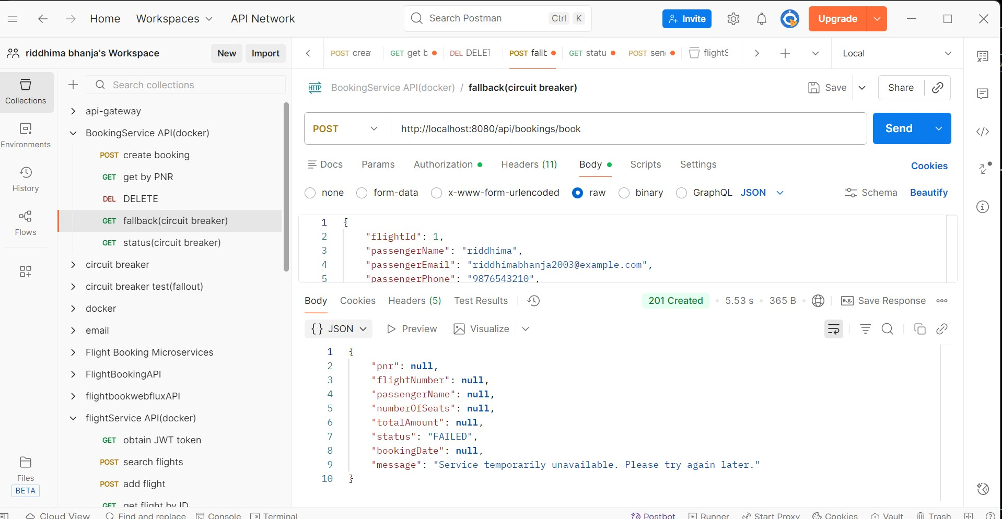

**SEND EMAIL**

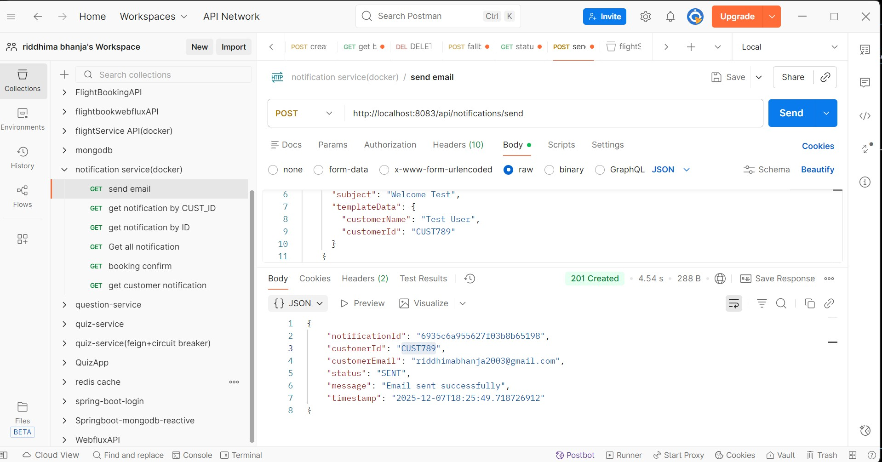

**GET BY ID**

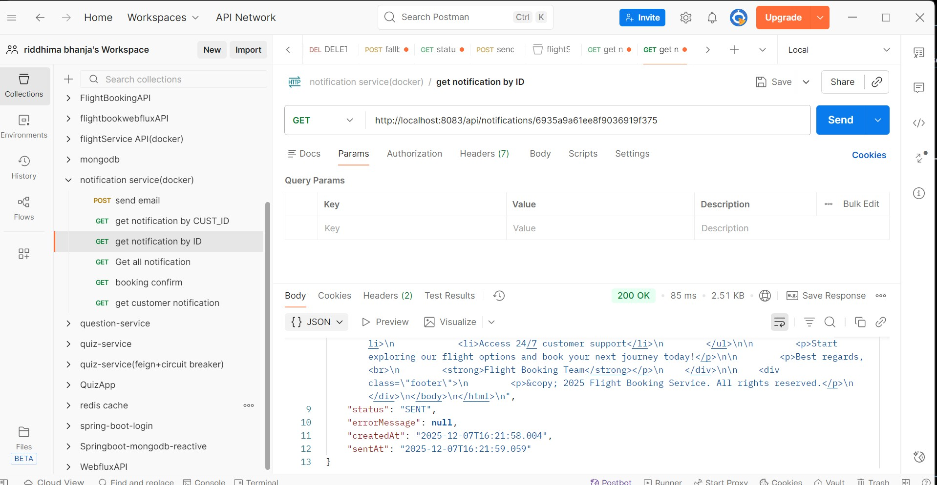

**BOOKING CONFIRMATION EMAIL**

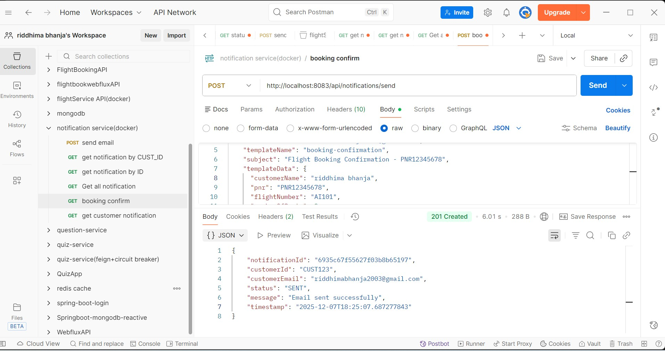

**GET ALL NOTIFICATION**

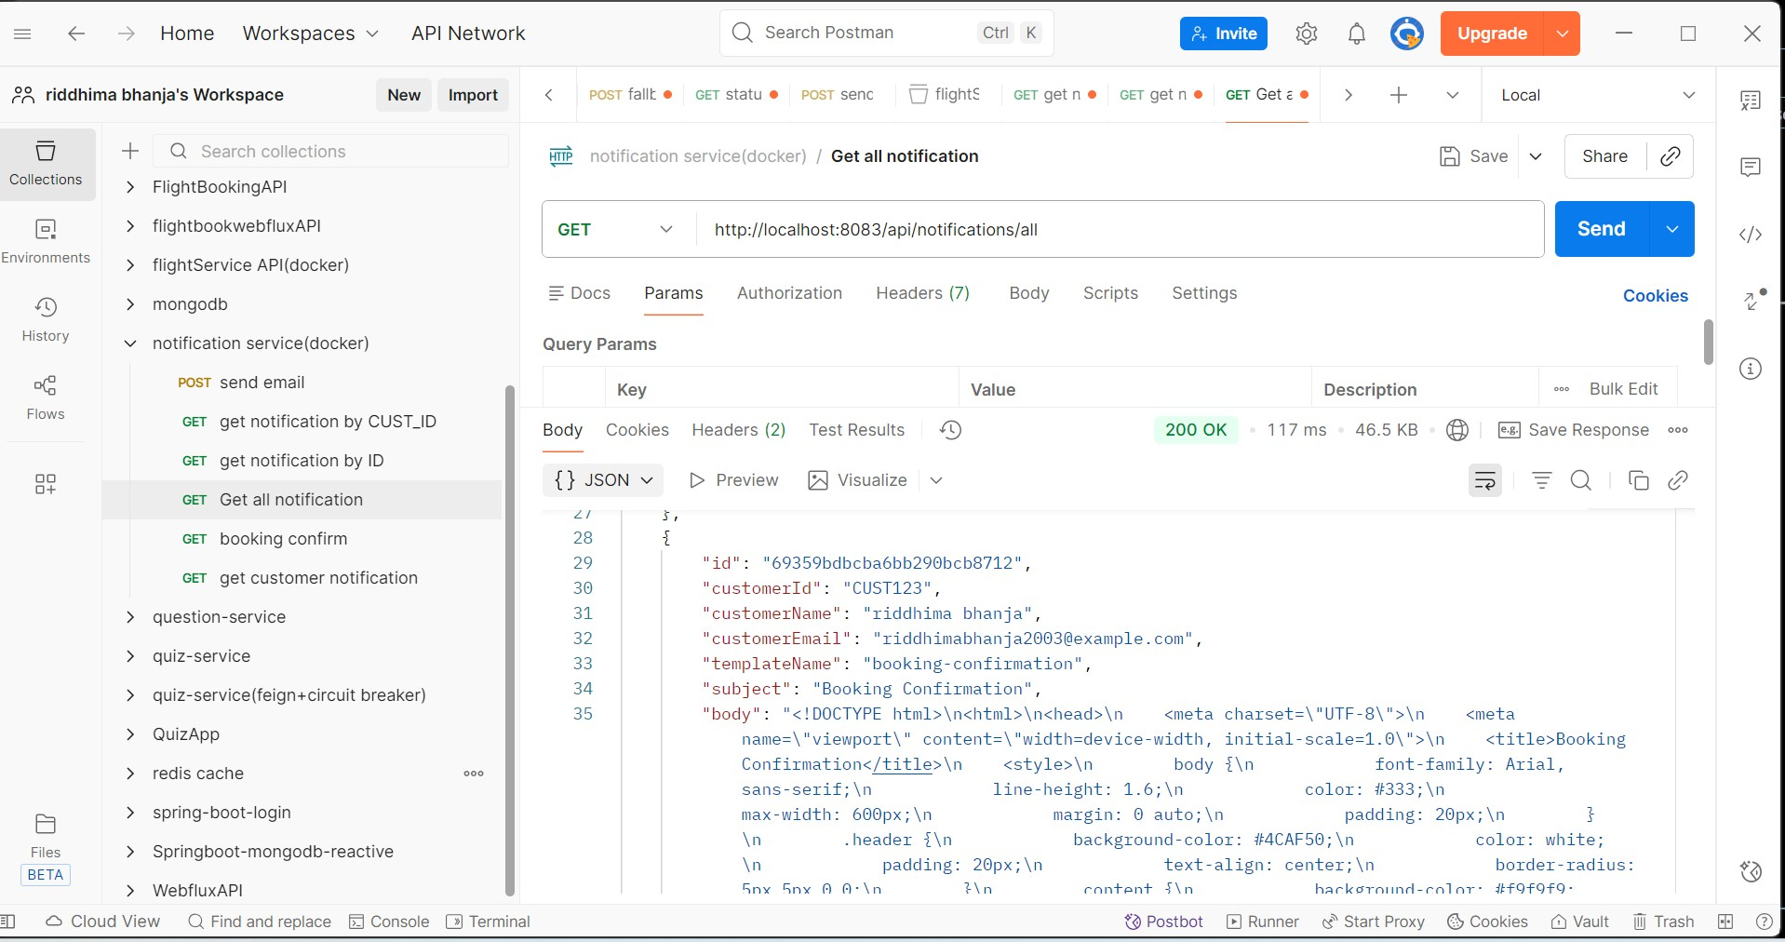

**GET CUSTOMER NOTIFICATION**

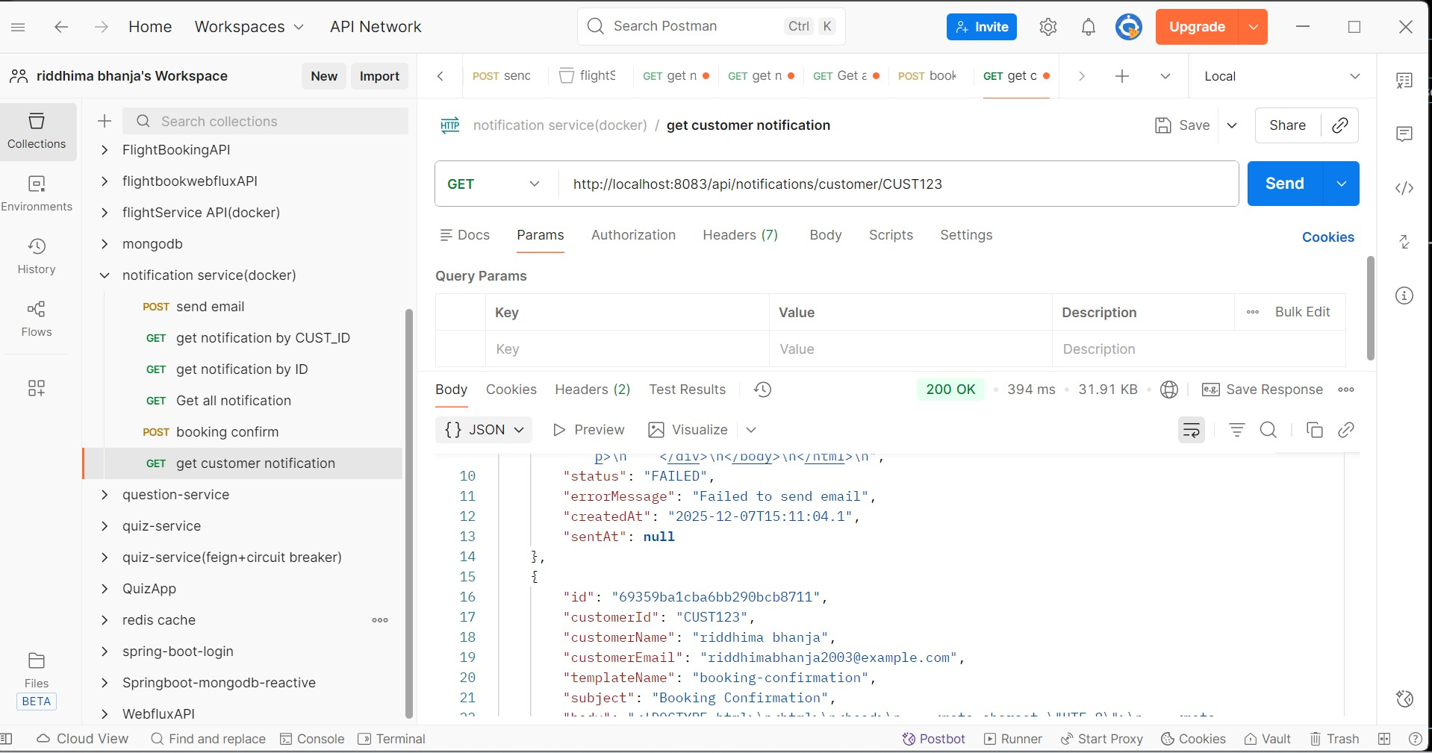

**CREATE BOOKING**

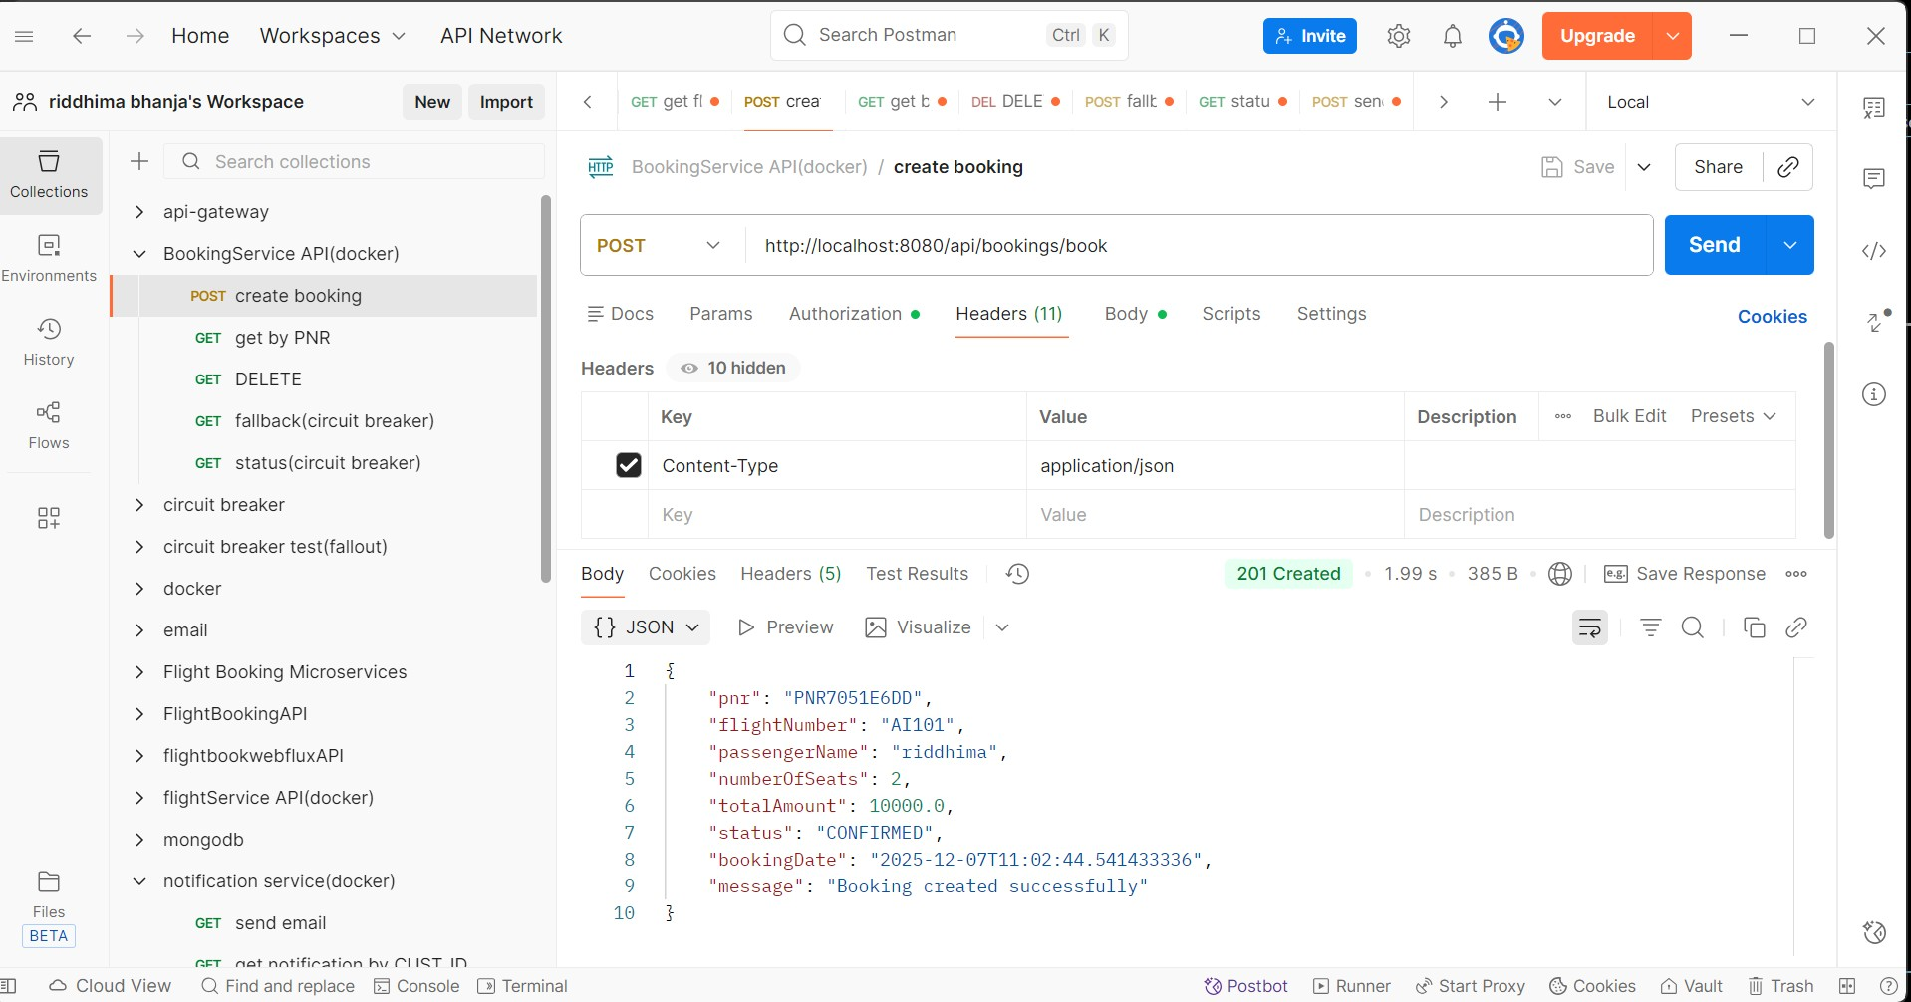

* Jmeter result tree

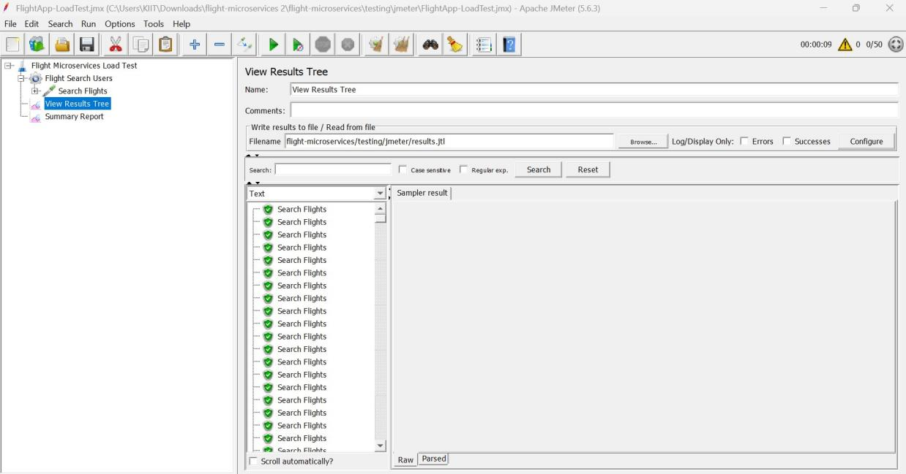

* **Jmeter Summary report**

**20 Requests**

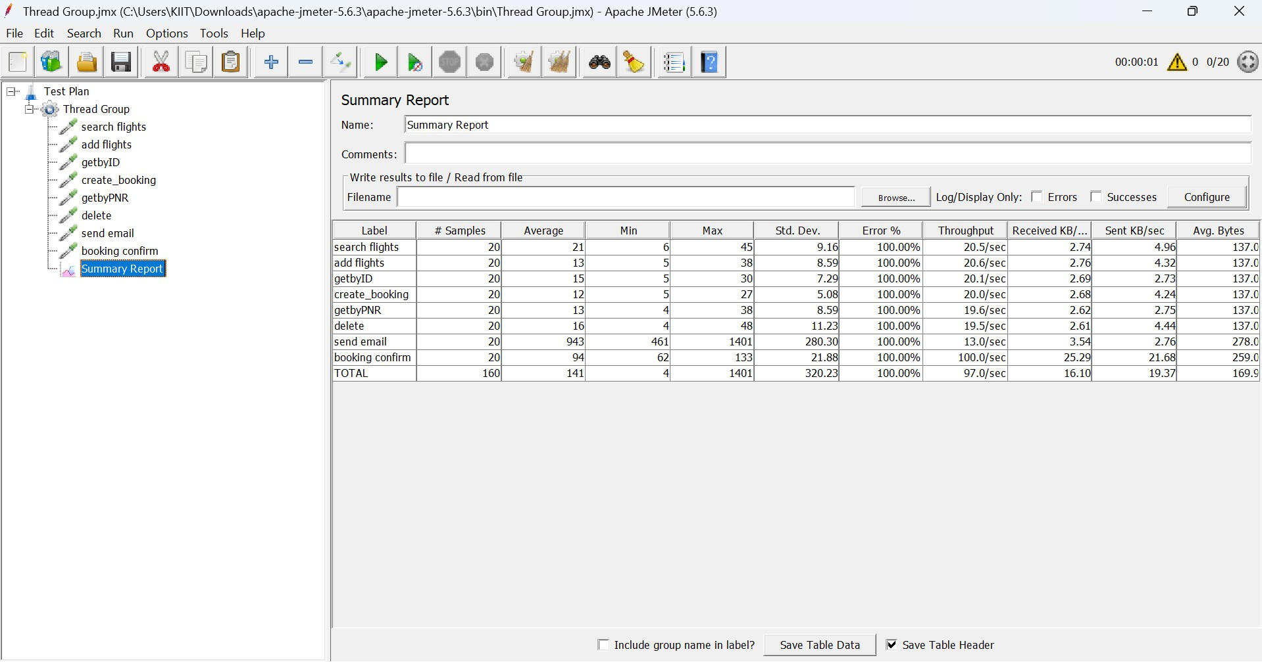

**50 Requests**

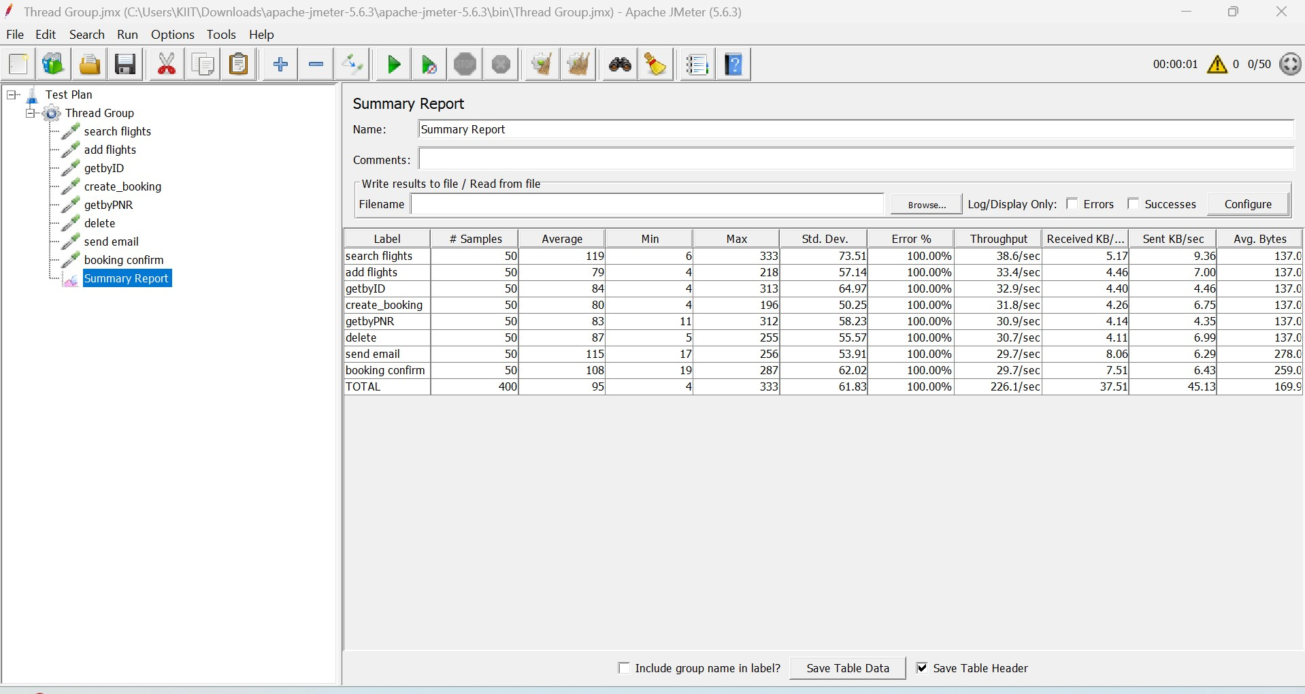

**100 Requests**

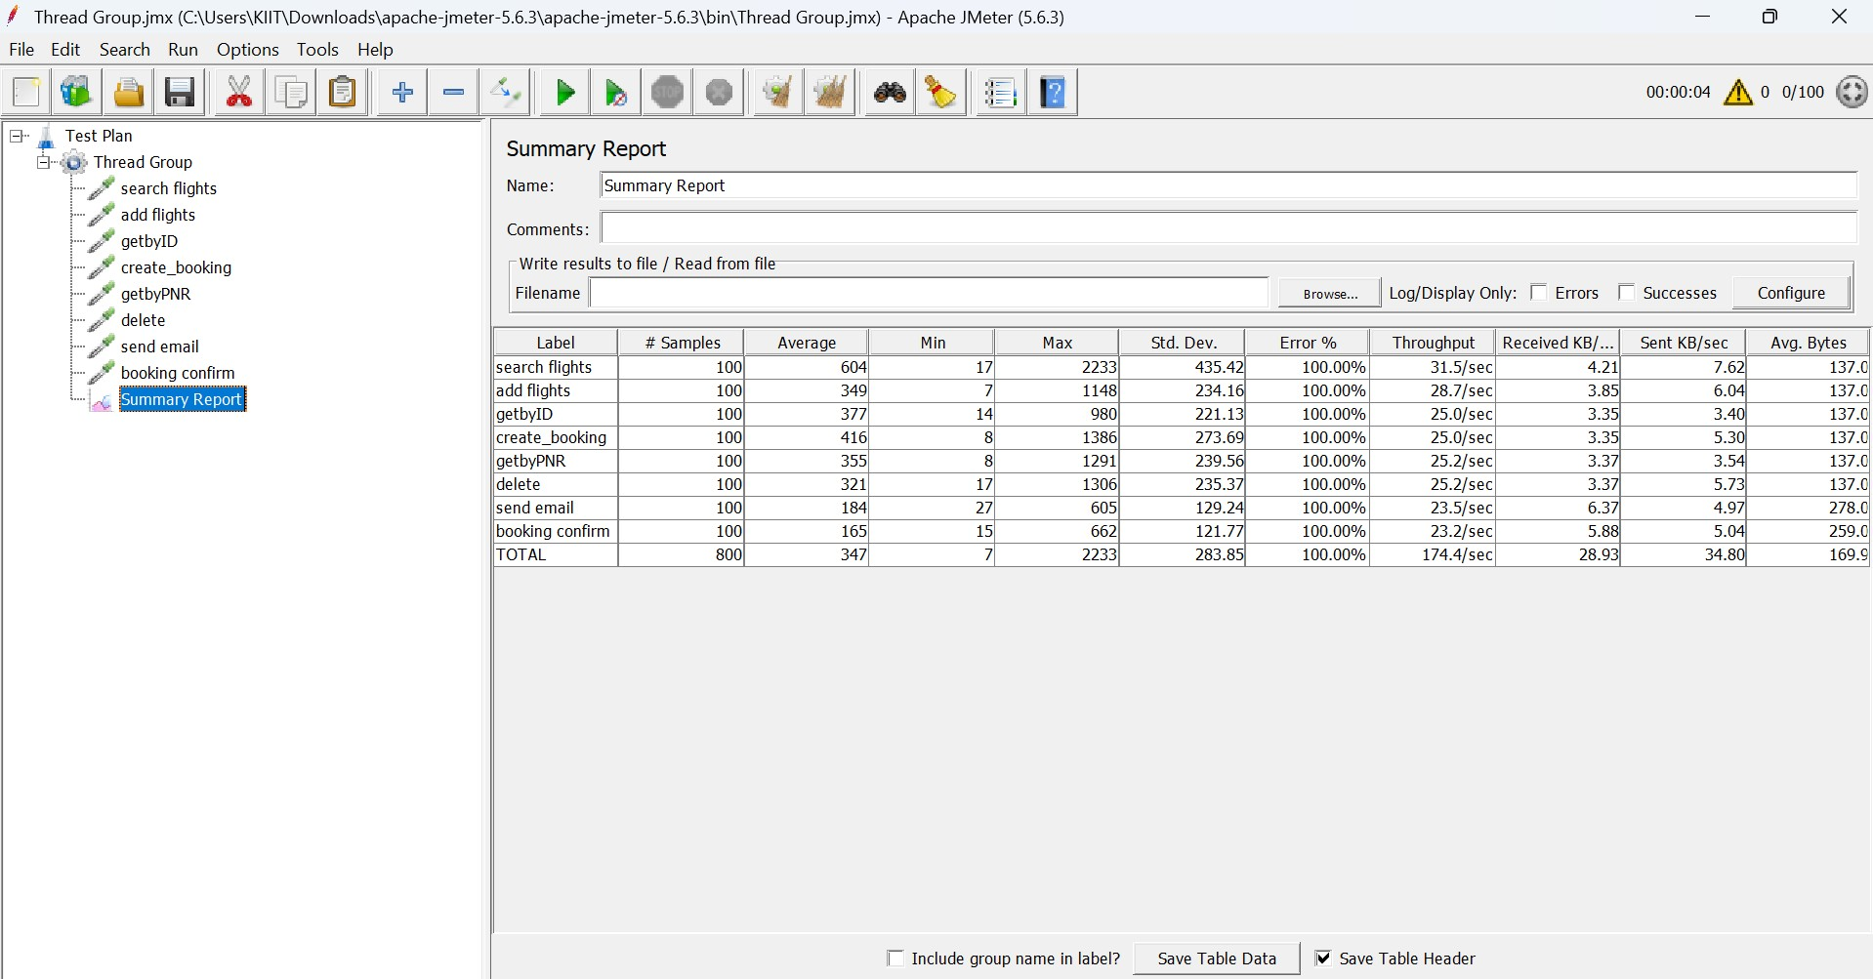

MySQL Workbench

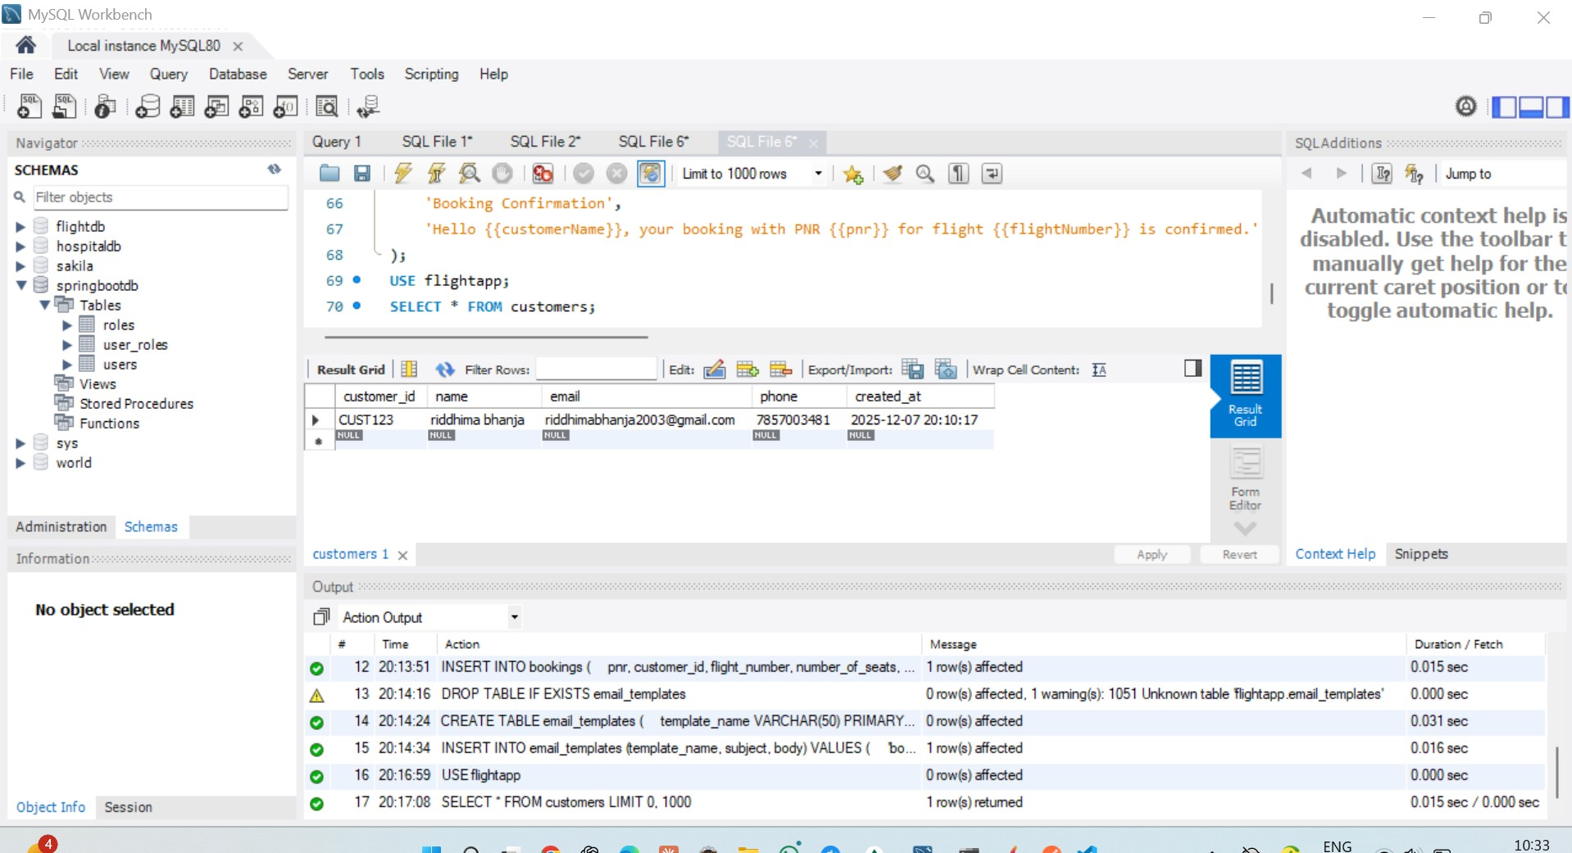

**EUREKA DASHBOARD**

